

User Interface Design(23CSE111)

LAB MANUAL

Submitted by: -
NAME: | CH. JAI RAM CHARAN
ROLL NO: | AV.SC.U4CSE25106
YEAR/SEM/SECTION: | 1ST YR/SEM-2/CSE-B
Submitted to: -
NAME: | Dr. Rajkumar Batchu
DEPARTMENT: | CSE
DESIGNATION: | Assistant Professor

MARKS:

INDEX

S.NO | TITLE | PAGE  NO | REMARKS
1. | WEEK-1  A. To understand the installation process of a VS code and get familiar with its environment for web development.  B. To learn the basic structure of an HTML document and create a simple webpage using headings and paragraphs.  C. To understand and implement basic HTML tags such as image, hyperlink, text formatting, and inline styling to design a simple webpage. | 9-19
2. | WEEK-2  - To design a simple web page using HTML that demonstrates the use of background color, background image, heading styling, and preformatted text.  - To create a static webpage using only HTML that displays basic information about Amrita Vishwa Vidyapeetham, including a heading, descriptive text, background styling through HTML attributes, and a table showing the list of campuses in different states  - To design a restaurants menu webpage using HTML and displaying menu items in a table format with proper layout and visual styling. | 20-30
3. | WEEK-3  - To design and develop an academic timetable using HTML tables by applying row span, column span, and styling for proper structure and presentation.  - To create a comprehensive webpage that includes an academic timetable along with syllabus representation using images and structured HTML elements. | 31-47
4. | WEEK-4  - To understand the concept of forms and design a structured student registration form using HTML tables, including various input types such as text fields, radio buttons, checkboxes, file upload, and dropdown lists.  - To understand the concept of forms and design user login and registration webpages using HTML, and to display them within a single interface using iframe for better layout and user interaction. | 48-58
5. | WEEK-5  - To create a responsive card layout using HTML and CSS with three cards, each containing an image, title, and button.  - To design a mini website using iframe with navigation links (Home, About, Contact), where clicking on each link displays the respective content within the same page using internal or external CSS.  - To design an Amrita login page using HTML and CSS that displays different campuses, where clicking on each campus shows its details on the same page | 59-71
6. | WEEK-6  - Design a responsive e-commerce application using the grid layout. This application should contain different categories of products such as electronics, clothing, home-appliances, books.  - Design a responsive e-commerce application using the grid layout. This application should contain different categories of products such as electronics, clothing, home-appliances, books. Based on the category we select corresponding products should be displayed on the sidebar | 72-88
7. | WEEK-7  - Create a github account and create a repository named UIDLAB-CSE25106 and upload every week experiments, lab report in that repository and make the repository private. | 89-92
8. | WEEK-8  - Create a webpage that displays a square that continuously rotates 360 using CSS.  - Create a ball that moves up and down continuously using CSS animation.  - Create a circle that moves horizontally and rotates at the same time. | 92-97
9. | WEEK-9  - A1. Write a JavaScript program to determine if a number is even or odd  A2. Write a JavaScript program to determine if a number is prime or not.  A3. Write a JavaScript program to find the factorial of a given number.  A4. Write a JavaScript program to determine if a number is Armstrong or not. | 98-103
10. | WEEK-10  - Write a JavaScript conditional statement to find the sign of product of three numbers using functions .Display an alert box with the specified sign.  - Write a JavaScript conditional statement to sort three numbers using functions .Display an alert box to show the result.  - Write a JavaScript conditional statement to find the largest of five numbers using function and onclick event .Display an alert box to show the result.  - Write a JavaScript for loop that will iterate from 0 to 15. For each iteration, it will check if the current number is odd or even, and display a message to the screen.  - Write a JavaScript program which iterates the integers from 1 to 100. But for multiples of three print “LOL" instead of the number and for the multiples of five print “OK". For numbers which are multiples of both three and five print “LOL-OK".  - Write a JavaScript program to read 6 subjects marks from the student then compute the average marks of the student. Then, this average is used to determine the corresponding grade. | 104-119
11. | WEEK-11  - A website requires users to enter a username. The system should display a message while typing if the username is less than 5 characters.  - A registration form should validate email format before submission. If invalid, the form should not be submitted.  - A system should check password strength while typing and display whether it is weak or strong.  - A form should validate a mobile number when the user leaves the input field. The number must be exactly 10 digits.  - Design an HTML page, such that the registration form must validate:  Name (not empty)  Email (valid format)  Password (minimum 6 characters) | 120-130
12. | WEEK-12  - The setup and installation process of Electron.js and node.js corresponding to its output.

Week-1

- Downloading and Installing Visual Studio Code (VS Code):
- Aim: To understand the installation process of a VS code and get familiar with its environment for web development
- Procedure:
- Step-1: Visit the official VS code website to get the downloadable file. Here is website link https://code.visualstudio.com/download.

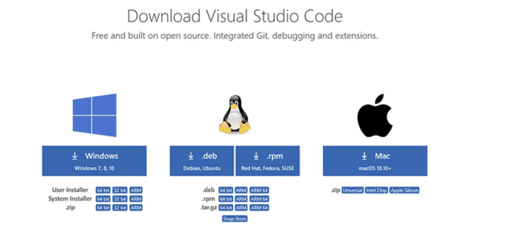

- Step-2: Click on the download Option based on the Operating system.
- Step-3: Click on the downloaded file to Install.
- Step-4: Accept the agreement and click on “Next”.
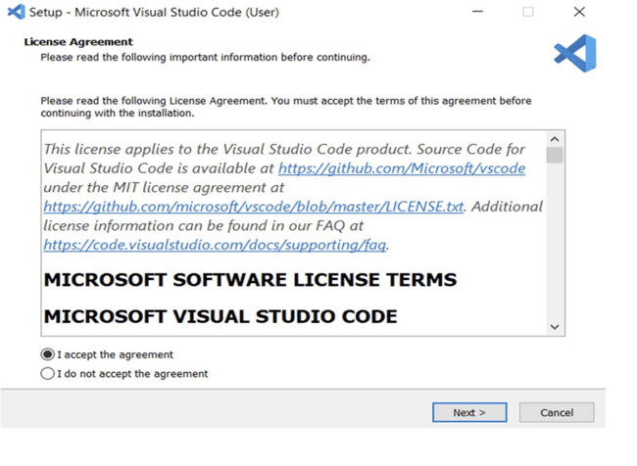
- Step-5: Select a folder by clicking Browse or continue with the default path. Click “Next”.

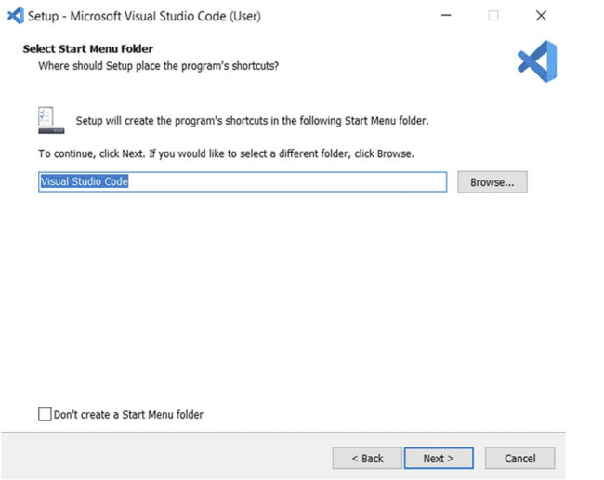

- Step-6: Select the required options and click “Next”.

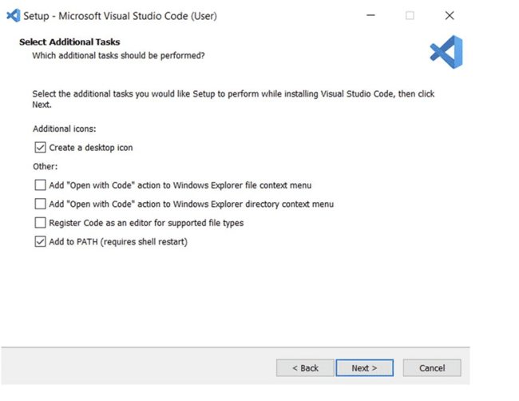

- Step-7: Select “Install”.

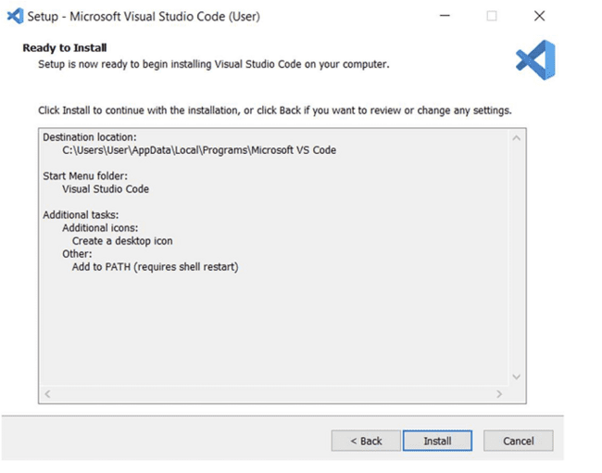

- Step-8: Click “Finish” after installing successfully.

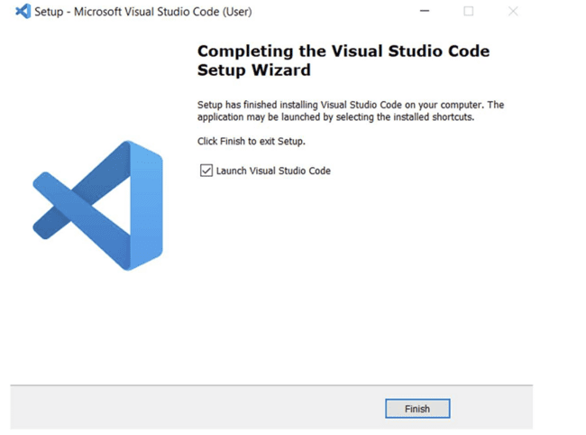

- Step-9: Open VS code and go to Extensions tab on the left side panel, search for “Open in browser” extension and download that extension.

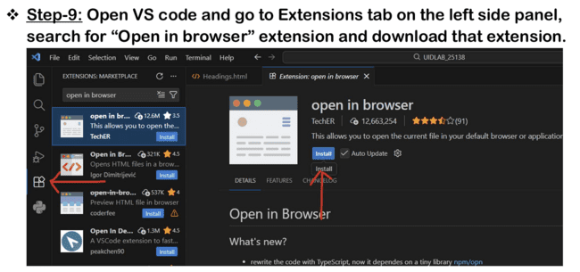
These are the steps to download VS Code in your computer.

- Understanding structure of HTML:
- Aim: To learn the basic structure of an HTML document and create a simple webpage using headings and paragraphs.
- Program:
- Input:
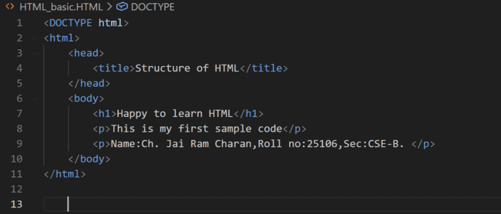

- Output:

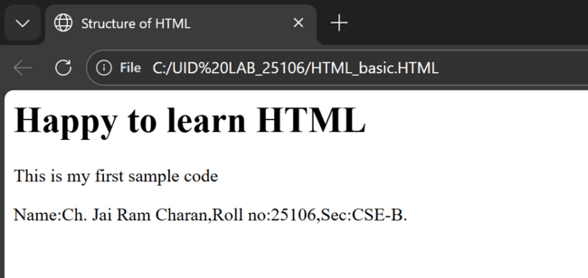

- Explanation:
  - <!DOCTYPE html>
The <!DOCTYPE html> declaration defines that this document is an HTML5 document.
- <html>
- This is the main element of the HTML document.
- Everything on the webpage will be inside this tag.
- We use </html> to close this.
- <head>
- The head section contains information about the page.
- Things here are not shown directly on the webpage.
- This contains information that is applied to whole webpage like images or colour to the web page.
- We use </head> to close this.
- <title>
- Sets the title of the webpage.
- This text appears on the Browser tab.
- We </title> to close this.
- <body>
- This is the visible part of the webpage.
- Everything the user sees (text, images, buttons, forms, etc.) goes here.
- We </body> to close this.

- Understanding the basic html tags:
- Aim: To understand and implement basic HTML tags such as image, hyperlink, text formatting, and inline styling to design a simple webpage.
- Program:
- Input:

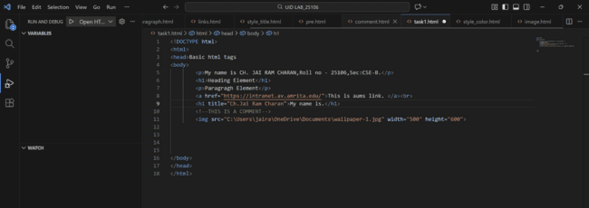

- Output:

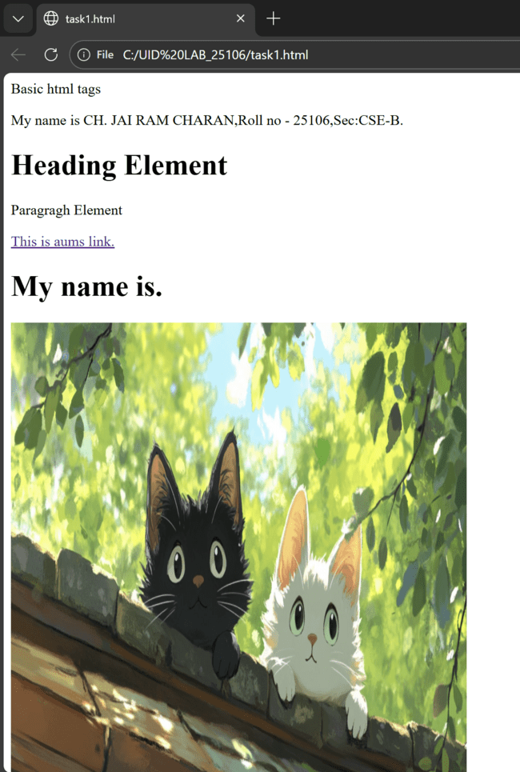
- Explanation:
- <h1></h1>
- It Is Heading tag.
- There are total of 6 heading tags from h1 to h6, h1 is highest and h6 is smallest.
- Used for main titles of a page. ϖ
- <p></p>
- Paragraph tag.
- Used for normal text content.
- Any extra spaces than 1 space is removed automatically in-between sentence.
- <a href=””></a>
- Anchor tag → used to create links.
- href = Hypertext Reference (link address).
- Can link to:
• Websites.
• Other pages.
• Sections in the same page.
- <br>
- Line break tag.
- Moves content to the next line.
- It has no closing tag.
- <img>
- Used to display images.
- “src” attribute contains source of image (image URL).
- “alt” attribute contains alternate text to display if image is not displayed.
- “width” and “height” attributes of the image are also passed into this tag.
- It is a self-closing tag.

Week-2
- To design a simple web page using HTML that demonstrates the use of background color, background image, heading styling, and preformatted text.
- Aim: To design a simple web page using HTML that demonstrates the use of background color, background image, heading styling, and preformatted text.
- Program:
- Input:

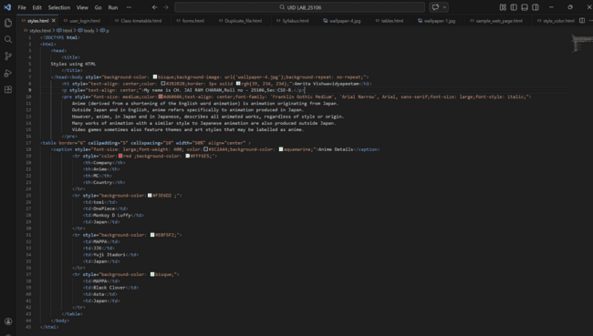

- Output:

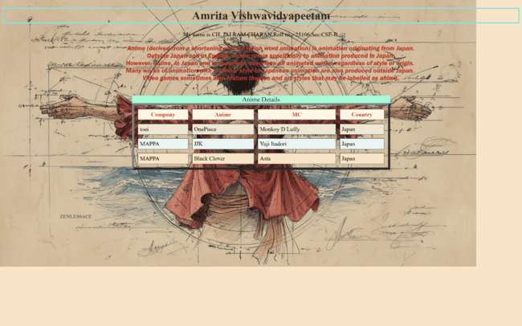

- Explanation:
- HTML-Hyper Text Markup Language.
- <DOCTYPE HTML>: Tells the browser about HTML version.
- <html>: Root element of an HTML page.
- <head>: Contains information about the HTML page.
- <title>: Specifies a title for the HTML page.
- <body>: Contains contents like images, links, etc.
- <h1> and <h2>: Defines heading .1 and 2 defines sizes.
- <pre>: defines preformatted text.
- style: style attribute for styling HTML elements.
- color: for text color.
- background-color: for background color.
- background-image: for background Image.
- background-size: for setting the background size.
- border: for border.
- align: for alignment.
- <table>: Defines a table
- <caption>: Defines a table caption
- <col>: Specifies column properties for each column within a <colgroup> element.
- <colgroup>: Specifies a group of one or more columns in a table for formatting
- <tr>: Defines a row in a table
- <th>: Defines a header cell in a table
- <td>: Defines a cell in a table
- <br>: defines a line break.

- To create a static webpage using only HTML that displays basic information about Amrita Vishwa Vidyapeetham, including a heading, descriptive text, background styling through HTML attributes, and a table showing the list of campuses in different states.
- Aim: To create a static webpage using only HTML that displays basic information about Amrita Vishwa Vidyapeetham, including a heading, descriptive text, background styling through HTML attributes, and a table showing the list of campuses in different states.
- Procedure:
- Input:
- <!DOCTYPE html>
- <html>
- <head>
- <title style="color: brown;"> Amrita Vishwavidyapeetham </title>
- </head>
- <body style="background-color: bisque;background-image: url(amaravathi.campus.jpg);background-repeat: no-repeat;background-size:cover;">
- <p style="text-align: center;">My name is CH. JAI RAM CHARAN,Roll no - 25106,Sec:CSE-B.</p>
- <h1 style="color:maroon;text-align: center;border: 3px solid rgb(20,
- 27, 90);">Amrita Vishwavidyapeetham</h1>
- <pre style="font-style: oblique;font-family: 'Times New Roman', Times,
- serif;font-size: large;color:black;text-align: center;">
- Amrita Vishwa Vidyapeetham, commonly known as Amrita University,
- multi-disciplinary university in India.
- Founded in 1994 by Mata Amritanandamayi Devi (Amma).
- Accredited with the highest possible ‘A++’ grade by NAAC.

- To create a static webpage using only HTML that displays basic
- information about Amrita Vishwa Vidyapeetham, including a heading,
- descriptive text, background styling through HTML attributes, and a
- table showing the list of campuses in different states.
- </pre>
- <table border="1" cellpadding="5" cellspacing="10" width="50%"align="center" style="background-image: url(amrita\ inside.jpg);">
- <caption style="font-size: x-large;font-weight: 400;color: rgb(0, 0, 0);background-color:rgb(175, 216, 212);">Amrita Campus Branches</caption>
- <colgroup>
- <col style="background-color: bisque;">
- </colgroup>
- <tr><colgroup>
- <col style="background-color: wheat;"> </colgroup>
- <colgroup><col style="background-color: wheat;"></colgroup>
- <th style="background-color: white;color: rgb(185, 88, 88);">S.NO</th>
- <th style="background-color: white;color: rgb(190, 92, 92);">Campus Name</th>
- <th style="background-color: white;color: rgb(193, 92, 92);">Campus Location</th>
- </tr>
- <tr>
- <td>1.</td>
- <td>Amaravati</td>
- <td>Andhra pradesh</td>
- </tr>
- <tr>
- <td>2.</td>
- <td>Amritapuri</td>
- <td>Kerala</td>
- </tr>
- <tr>
- <td>3.</td>
- <td>Bengaluru</td>
- <td>Karnataka</td>
- </tr>
- <tr>
- <td>4.</td>
- <td>Chennai</td>
- <td rowspan="2">Tamil Nadu</td>
- </tr>
- <tr>
- <td>5.</td>
- <td>Coimbatore</td>
- </tr>
- <tr>
- <td>6.</td>
- <td>Faridabad</td>
- <td>Haryana</td>
- </tr>
- <tr>
- <td>7.</td>
- <td>Kochi</td>
- <td>Kerala</td>
- </tr>
- </tr>
- </table>
- </body>
- </html>

- Output:
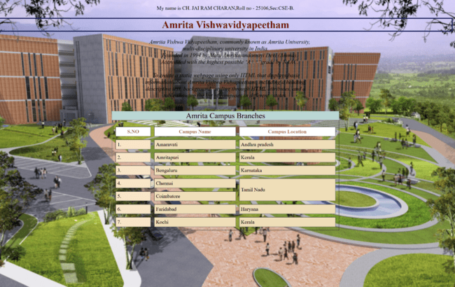
- Explanation:
- HTML-Hyper Text Markup Language.
- <DOCTYPE HTML>: Tells the browser about HTML version.
- <html>: Root element of an HTML page.
- <head>: Contains information about the HTML page.
- <title>: Specifies a title for the HTML page.
- <body>: Contains contents like images, links, etc.
- <h1> and <h2>: Defines heading .1 and 2 defines sizes.
- <pre>: defines preformatted text.
- style: style attribute for styling HTML elements.
- color: for text color.
- background-color: for background color.
- background-image: for background Image.
- background-size: for setting the background size.
- border: for border.
- align: for alignment.
- <table>: Defines a table
- <caption>: Defines a table caption
- <col>: Specifies column properties for each column
- within a <colgroup> element.
- <colgroup>: Specifies a group of one or more
- columns in a table for formatting
- <tr>: Defines a row in a table
- <th>: Defines a header cell in a table
- <td>: Defines a cell in a table
- <br>: defines a line break.

- To design a restaurants menu webpage using HTML and displaying menu items in a table format with proper layout and visual styling.

- Aim: To design a restaurants menu webpage using HTML and displaying menu items in a table format with proper layout and visual styling.
- Procedure:
Input:
<!DOCTYPE html>
<html>
<head>
<title>2c</title>
</head>
<body style="background-image: url(menu.jpg); background-repeat: no-repeat;background-size: cover;">
<br>
<br>
<p style="text-align: center;color:red;font-size: large;">My name is CH. JAI RAM CHARAN,Roll no - 25106,Sec:CSE-B.</p>
<br>
<br>
<h1 style="text-align: center;"> Our Restaurant Menu</h1>
<br>
<br>
<table border="6" cellspacing="5" cellpadding="5" align="center"width="50%">
<tr style="color: brown; font-size: large; background-color: burlywood;">
<th >Item</th>
<th>Price($)</th>
</tr>
<tr style="background-color:rgb(248, 227, 188);">
<th>1.Momos</th>
<th>15$</th>
</tr>
<tr style="background-color:rgb(248, 227, 188);">
<th>2.Nuddles</th>
<th>$20</th>
</tr>
<tr style="background-color:rgb(248, 227, 188);">
<th>3.Sushi</th>
<th>$18</th>
</tr>
<tr style="background-color:rgb(248, 227, 188);">
<th>4.Ramen</th>
<th>$15</th>
</tr>
<tr style="background-color:rgb(248, 227, 188);">
<th>5.Udon</th>
<th>$10</th>
</tr>
<tr style="background-color:rgb(248, 227, 188);">
<th>6.Water Bottle</th>
<th>$2</th>
</tr>
</table>
</body>
</html>

- Output:

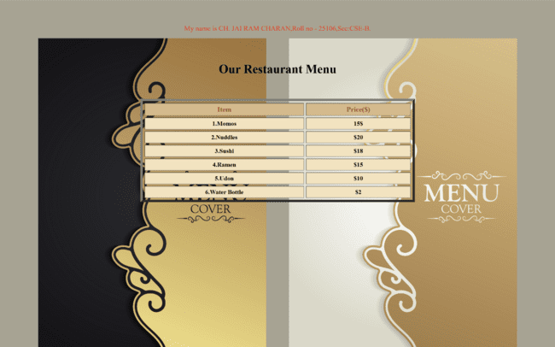
- Explanation:
- HTML-Hyper Text Markup Language.
- <DOCTYPE HTML>: Tells the browser about HTML version.
- <html>: Root element of an HTML page.
- <head>: Contains information about the HTML page.
- <title>: Specifies a title for the HTML page.
- <body>: Contains contents like images, links, etc.
- <h1> and <h2>: Defines heading .1 and 2 defines sizes.
- <pre>: defines preformatted text.
- style: style attribute for styling HTML elements.
- color: for text color.
- background-color: for background color.
- background-image: for background Image.
- background-size: for setting the background size.
- border: for border.
- align: for alignment.
- <table>: Defines a table
- <caption>: Defines a table caption
- <col>: Specifies column properties for each column
- within a <colgroup> element.
- <colgroup>: Specifies a group of one or more
- columns in a table for formatting
- <tr>: Defines a row in a table
- <th>: Defines a header cell in a table
- <td>: Defines a cell in a table
- <br>: defines a line break.

Week-3
- To design and develop an academic timetable using HTML tables by applying row span, column span, and styling for proper structure and presentation.
- Aim: To design and develop an academic timetable using HTML tables by applying row span, column span, and styling for proper structure and presentation.
- Program:
- Input:
- <!DOCTYPE html>
- <html>
- <head>
- <title>CSE-B Time Table</title>
- </head>
- <body>
- <h1 style="text-align: center;"> TIME TABLE </h1>
- <p style="text-align: center;">My name is CH. JAI RAM CHARAN,Roll no - 25106,Sec:CSE-B.</p>
- <table border ="2" width="50%" align="center" style="border-collapse: collapse;">
- <tr>
- <th style="text-align: center;" colspan="12">Master Time Table CSE II Semester B Section </th>
- </tr>
- <tr>
- <td colspan="4">Dept.CSE</td>
- <td colspan="8" rowspan="3">Class Room Venue: 511</td>
- </tr>
- <tr>
- <td colspan="4"> Class: B.Tech CSE-B</td>
- </tr>
- <tr>
- <td colspan="4"> Semester II</td>
- </tr>
- <tr>
- <td colspan="4" style="text-align:left;">
- <p>
- Class Advisors:
- 1.Name: Dr.Kurmala Gowri Raghavendra Narayan<br>
- Email: kgr_narayan@av.amrita.edu<br>
- Moblie Number: +91-9705409393<br>
- </p>
- </td>
- <td colspan="8">
- <p>
- 2.Name: Dr.Ankit Sachan<br>
- Email: s_ankit@av.amrita.edu<br>
- Moblie Number: +91-8381800129<br>
- </p>
- </td>
- </tr>
- <tr>
- <th rowspan="2">Time/Day</th>
- <th>slot 1</th>
- <th>Slot 2</th>
- <th rowspan="2">10:35am-10:45am</th>
- <th>Slot 3</th>
- <th>Slot 4</th>
- <th>Slot 5</th>
- <th rowspan="2">1:15pm-2:05pm</th>
- <th>Slot 6</th>
- <th rowspan="2">3:00pm-3:10pm</th>
- <th>Slot 7</th>
- <th>Slot 8</th>
- </tr>
- <th>8:55am-9:45am</th>
- <th>9:45am-10:35am</th>
- <th>10:45am-11:35am</th>
- <th>11:35am-12:25pm</th>
- <th>12:25pm-1:15pm</th>
- <th>2:10pm-3:00pm</th>
- <th>3:10pm-4:00pm</th>
- <th>4:00pm-4:50pm</th>
- </tr>
- <tr>
- <th>Monday</th>
- <td colspan="2">Linear Algebra LAB</td>
- <td rowspan="5" style="background-color: yellow; writing-mode: vertical-rl; text-align: center;">Short break</td>
- <td>LIBRARY</td>
- <td>Modern Physics</td>
- <td>LIBRARY</td>
- <td rowspan="5" style="background-color: yellow;writing-mode: vertical-lr; text-align: center;">Lunch Break</td>
- <td>Manufacturing Practice LAB</td>
- <td rowspan="5" style="background-color: yellow; writing-mode: vertical-rl; text-align: center;">Short break</td>
- <td colspan="2">Manufacturing Practice LAB</td>
- </tr>
- <tr>
- <th>Tuesday</th>
- <td>Discrete Mathematics</td>
- <td>Linear Algebra</td>
- <td>Modern Physics</td>
- <td>Object Oriented Programming</td>
- <td>User Interface Design</td>
- <td>LIBRARY</td>
- <td colspan="2">Glimpses of Glorious India</td>
- </tr>
- <tr>
- <th>Wednesday</th>
- <td colspan="2">Object Oriented Programming</td>
- <td>Discrete Mathematics</td>
- <td>User Interface Design</td>
- <td>Glimpses of Glorious India</td>
- <td style="color: red;">COUNSELLING</td>
- <td colspan="2">LIBRARY</td>
- </tr>
- <tr>
- <th>Thursday</th>
- <td>Linear Algebra</td>
- <td>Object Oriented Programming</td>
- <td>Discrete Mathematics</td>
- <td style="color: red;">COUNSELLING</td>
- <td>LIBRARY</td>
- <td>Modern Physics</td>
- <td colspan="2">LIBRARY</td>
- </tr>
- <tr>
- <th>Friday</th>
- <td colspan="2">User Interface Design LAB BYOD </td>
- <td>Linear Algebra</td>
- <td>Object Oriented Programming</td>
- <td>LIBRARY</td>
- <td>Glimpses of Glorious India</td>
- <td colspan="2">Discrete Mathematics LAB</td>
- </tr>
- <tr>
- <th>Course Code</th>
- <th colspan="2">Course Name</th>
- <th></th>
- <th> L-T-P</th>
- <th>Credits</th>
- <th colspan="3">Faculty Name</th>

- <th></th>
- <th colspan="2"> Assisting Faculty</th>
- </tr>
- <tr>
- <th>23MAT116</th>
- <td colspan="2">Discrete Mathematics</td>
- <td></td>
- <th>3-0-2</th>
- <th>4</th>
- <td colspan="3">Dr.Srivivasa Rao Thota</td>
- <td></td>
- <td colspan="2"></td>
- </tr>
- <tr>
- <th>23MAT117</th>
- <td colspan="2">Linear Algebra</td>
- <td></td>
- <th>3-0-2</th>
- <th>4</th>
- <td colspan="3">Mr.Sapavat Bixapathi</td>
- <td></td>
- <td colspan="2"></td>
- </tr>
- <tr>
- <th>23CSE111</th>
- <td colspan="2">Object Oriented Programming</td>
- <td></td>
- <th>3-0-2</th>
- <th>4</th>
- <td colspan="3">Dr. Balaji TK</td>
- <td></td>
- <td colspan="2"></td>
- </tr>
- <tr>
- <th>23PHY115</th>
- <td colspan="2">Modern Physics</td>

- <td></td>
- <th> 2-1-0</th>
- <th>3</th>
- <td colspan="3">Dr. C R Kesavalu</td>
- <td></td>
- <td colspan="2"></td>
- </tr>
- <tr>
- <th>23CSE113</th>
- <td colspan="2">User Interface Design</td>
- <td></td>
- <th>2-0-2</th>
- <th>3</th>
- <td colspan="3">Dr.Rajkumar Batchu</td>
- <td></td>
- <td colspan="2">Mr. Barge Bharadwaj</td>
- </tr>
- <tr>
- <th>23MEE115</th>
- <td colspan="2">Manufacturing Practice</td>
- <td></td>
- <th>0-0-3</th>
- <th>1</th>
- <td colspan="3">Dr. Sathies S.</td>
- <td></td>
- <td colspan="2"></td>
- </tr>
- <tr>
- <th>22ADM111</th>
- <td colspan="2">Glimpses of Glorious India</td>
- <td></td>
- <th>2-0-1</th>
- <th>2</th>
- <td colspan="3">Dr. Siva Panuganti</td>
- <td></td>
- <td colspan="2"></td>

- </tr>
- <tr>
- <th></th>
- <td colspan="2">Total (15L + 1Tut +12P =28 hrs)</td>
- <td></td>
- <th>15-1-12</th>
- <th>21</th>
- <td colspan="3"></td>
- <td></td>
- <td colspan="2"></td>
- </tr>
- </table>
- </body>
- </html>

- Output:
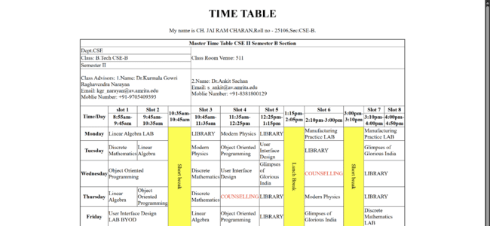
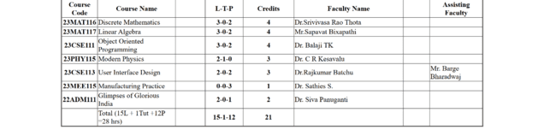

- Explanation:
- HTML-Hyper Text Markup Language.
- <DOCTYPE HTML>: Tells the browser about HTML version.
- <html>: Root element of an HTML page.
- <head>: Contains information about the HTML page.
- <title>: Specifies a title for the HTML page.
- <body>: Contains contents like images, links, etc.
- <h1> and <h2>: Defines heading .1 and 2 defines sizes.
- <pre>: defines preformatted text.
- style: style attribute for styling HTML elements.
- color: for text color.
- background-color: for background color.
- background-image: for background Image.
- background-size: for setting the background size.
- border: for border.
- align: for alignment.
- <table>: Defines a table
- border-collapse: sets whether table borders should collapse
into a single border or be separated
- <tr>: Defines a row in a table
- <th>: Defines a header cell in a table
- <td>: Defines a cell in a table
- <br>: defines a line break.
- colspan: To make a cell span over multiple columns
- rowspan: To make a cell span over multiple rows

- To create a comprehensive webpage that includes an academic timetable along with syllabus representation using images and structured HTML elements.
- Aim: To create a comprehensive webpage that includes an academic timetable along with syllabus representation using images and structured HTML elements..
- Program:
- Input:
- <!DOCTYPE html>
- <html>
- <head>
- <title>SEM-II Syllabus</title>
- <body style="background-color: beige;">
- <p style="background-color: white;">Name:Ch. Jai Ram Charan. Roll No:AV.SC.U4CSE25106 . Sec:CSE-B</p>
- <h1 style="text-align: center;">SEM-II Syllabus</h1>
- <h2 style="text-align: left;"> Discrete Mathematics</h2>

- <img src="DM.jpeg" width="1000">

- <h2 style="text-align: left;">Linear Algebra</h2>
- <img src="LI.jpeg" width="1000">

- <h2 style="text-align: left;">Object Oriented Programming</h2>
- <img src="OOPS.jpeg" width="1000">

- <h2 style="text-align: left;">Modern Physics</h2>
- <img src="MP.jpeg" width="1000">

- <h2 style="text-align: left;">User Interface Design</h2>
- <img src="UID.jpeg" width="1000">

- <h2 style="text-align: left;">Manufacturing Practice</h2>
- <img src="MANUFACTURE.jpeg" width="1000">

- <h2 style="text-align: left;">Glimpses of Glorious India</h2>
- <img src="GGI.jpeg" width="1000">

- <h2 style="text-align: center;color: black;">Class Calender</h2>
- <table border="1" cellspacing="0" cellpadding="1" width="90%" align="center" >

- <tr>
- <th colspan="12" style="text-align: center;">MASTER TIMETABLE CSE II SEMESTER B SECTION</th>
- </tr>
- <tr>
- <th colspan="4" style="text-align: left;">DEPT.CSE</th>
- <th colspan="8" rowspan="3" style="text-align: left;"> Class room:511</th>

- </tr>
- <tr>
- <th colspan="4" style="text-align: left;">Class:B-TECH. CSEB</th>

- </tr>
- <tr>
- <th colspan="4"style="text-align: left;">SEMSETER-II</th>

- </tr>
- <th colspan="4" style="text-align: left;"> Class Advisors:
- 1.Name:Dr. Kurmala Gowri Raghavendra Narayan</br>
- Email : kgr_narayan@av.amrita.edu</br>
- Mobile Number : +91-9705409393</br>

- </th>
- <th colspan="8" style="text-align: left;">2.Name:Dr.Ankit Schan
- Email : s_ankit@av.amrita.edu</br>
- Mobile Number :+91-8381800129</br>
- </th>

- </tr>
- <tr>
- <th>
- Time/day
- </th>
- <th style="white-space:nowrap;">Slot1<hr style="border-top: 3px solid black;">08.55-09.45am</th>
- <th style="white-space:nowrap;">Slot2<hr style="border-top: 3px solid black;">09.45-10.35am</th>
- <th style="white-space: nowrap;">10:35 to 10:45</th>
- <th style="white-space:nowrap;">slot3<hr border-top: style="border-top: 3px solid black;">10.45-11.35am</th>
- <th style="white-space:nowrap;">slot4<hr style="border-top: 3px solid black;">11.35am-12.25pm</th>
- <th style="white-space:nowrap;">slot5<hr style="border-top: 3px solid black;">12.25am-01.15pm</th>
- <th style="white-space: nowrap;">1:15 to 2:10</th>
- <th style="white-space:nowrap;">slot6<hr style="border-top: 3px solid black;">02.10-03.00pm</th>
- <th style="white-space: nowrap;">3:00 to 3:10</th>
- <th style="white-space:nowrap;">slot7<hr style="border-top: 3px solid black;">03.10-04.00pm</th>
- <th style="white-space:nowrap;">slot8<hr style="border-top: 3px solid black;">04.00-04.50pm</th>

- </tr>
- <tr>
- <th>Monday</th>
- <th colspan="2">23MAT117 Linear Algebra LAB(BYOD)</th>
- <th rowspan="5" style="background-color: yellow;writing-mode: vertical-lr;text-align: center;">Short break</th>
- <th>22ADM111 Glimpses of Glorious India</th>
- <th>23PHY115 Modern Physics</th>
- <th>LIBRARY</th>
- <th rowspan="5" style="background-color: yellow; writing-mode: vertical-lr;text-align: center;">Lucnh break</th>
- <th>23MEE115 Manufacturing Practice LAB</th>
- <th rowspan="5" style="background-color: yellow;writing-mode: vertical-lr;text-align: center;">Short break</th>
- <th colspan="2">23MEE115 Manufacturing Practice LAB</th>
- </tr>
- <tr>
- <th>Tuesday</th>
- <th>23MAT116 Discrete Mathematics</th>
- <th>23MAT117 Linear Algebra</th>
- <th>23PHY115 Modern Physics</th>
- <th>23CSE111Object Oriented Programming</th>
- <th>23CSE113 User Interface Design</th>
- <th>22ADM111Glimpses of Glorious India(P)</th>
- <th colspan="2" style="text-align: center;">Library</th>
- </tr>
- <tr>
- <th>Wednesday</th>
- <th colspan="2">23CSE111Object Oriented Programming_lab2</th>
- <th>23MAT116 Discrete Mathematics</th>
- <th>23CSE113 User Interface Design</th>
- <th>22ADM111Glimpses of Glorious India</th>
- <th>Library/Sports</th>
- <th colspan="2">Library/Sports</th>
- </tr>
- <tr>
- <th>Thursday</th>
- <th>23MAT117 Linear Algebra</th>
- <th>23CSE111 Object Oriented Programming</th>
- <th>23MAT116 Discrete Mathematics</th>
- <th style=" color: red;">Counselling</th>
- <th>Library</th>
- <th>23PHY115 Modern Physics(T)</th>
- <th colspan="2">Library/Sports</th>
- </tr>
- <tr>
- <th>Friday</th>
- <th colspan="2">23CSE113 User Interface Design Lab (BYOD)</th>
- <th>23MAT117 Linear Algebra</th>
- <th>23CSE111 Object Oriented Programming</th>
- <th>Library/Sports</th>
- <th style="color: red;">Counselling</th>
- <th colspan="2">23MAT116 Discrete Mathematics_lab_lab1</th>
- </tr>
- <tr>
- <th>Course Code</th>
- <th colspan="2">Course Name</th>
- <th></th>
- <th> L-T-P</th>
- <th>Credits</th>
- <th colspan="3">Faculty Name</th>

- <th></th>
- <th colspan="2"> Assisting Faculty</th>
- </tr>
- <tr>
- <th>23MAT116</th>
- <td colspan="2">Discrete Mathematics</td>
- <td></td>
- <th>3-0-2</th>
- <th>4</th>
- <td colspan="3">Dr.Srivivasa Rao Thota</td>
- <td></td>
- <td colspan="2"></td>
- </tr>
- <tr>
- <th>23MAT117</th>
- <td colspan="2">Linear Algebra</td>
- <td></td>
- <th>3-0-2</th>
- <th>4</th>
- <td colspan="3">Mr.Sapavat Bixapathi</td>
- <td></td>
- <td colspan="2"></td>
- </tr>
- <tr>
- <th>23CSE111</th>
- <td colspan="2">Object Oriented Programming</td>
- <td></td>
- <th>3-0-2</th>
- <th>4</th>
- <td colspan="3">Dr. Balaji TK</td>
- <td></td>
- <td colspan="2"></td>
- </tr>
- <tr>
- <th>23PHY115</th>
- <td colspan="2">Modern Physics</td>

- <td></td>
- <th> 2-1-0</th>
- <th>3</th>
- <td colspan="3">Dr. C R Kesavalu</td>
- <td></td>
- <td colspan="2"></td>
- </tr>
- <tr>
- <th>23CSE113</th>
- <td colspan="2">User Interface Design</td>
- <td></td>
- <th>2-0-2</th>
- <th>3</th>
- <td colspan="3">Dr.Rajkumar Batchu</td>
- <td></td>
- <td colspan="2">Mr. Barge Bharadwaj</td>
- </tr>
- <tr>
- <th>23MEE115</th>
- <td colspan="2">Manufacturing Practice</td>
- <td></td>
- <th>0-0-3</th>
- <th>1</th>
- <td colspan="3">Dr. Sathies S.</td>
- <td></td>
- <td colspan="2"></td>
- </tr>
- <tr>
- <th>22ADM111</th>
- <td colspan="2">Glimpses of Glorious India</td>
- <td></td>
- <th>2-0-1</th>
- <th>2</th>
- <td colspan="3">Dr. Siva Panuganti</td>
- <td></td>
- <td colspan="2"></td>

- </tr>
- <tr>
- <th></th>
- <td colspan="2">Total (15L + 1Tut +12P =28 hrs)</td>
- <td></td>
- <th>15-1-12</th>
- <th>21</th>
- <td colspan="3"></td>
- <td></td>
- <td colspan="2"></td>
- </tr>
- </table>

- </body>
- </head>
- </html>

- Output:
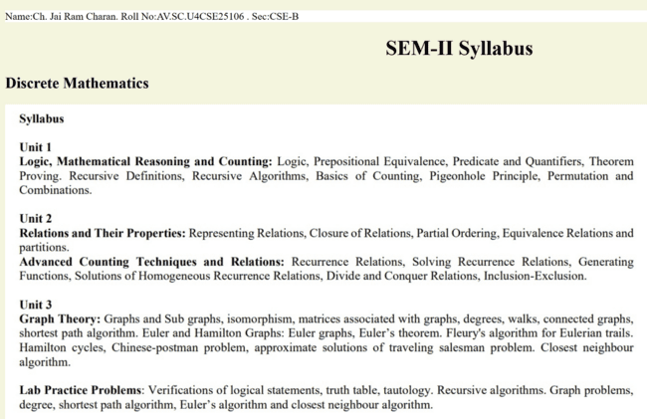
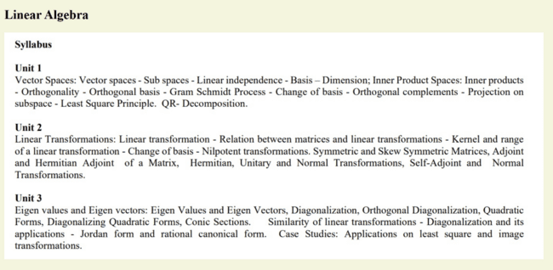
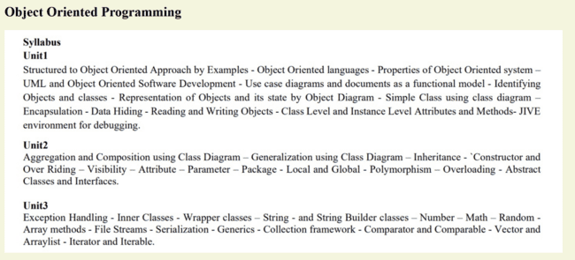
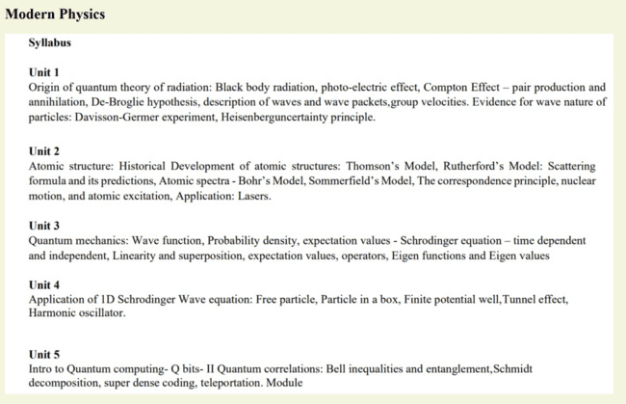
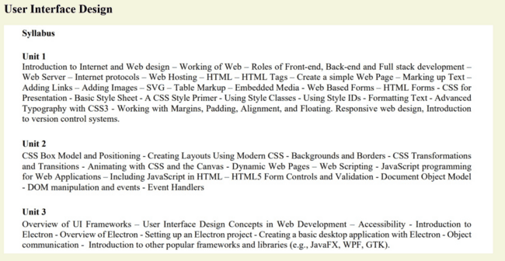
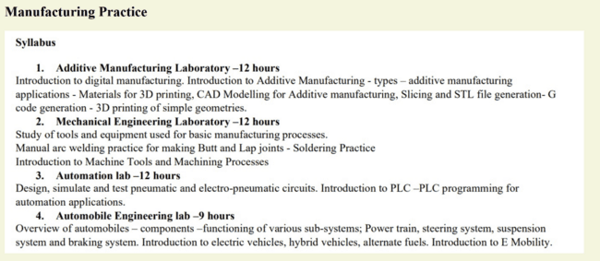
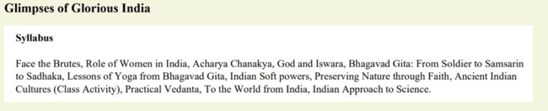
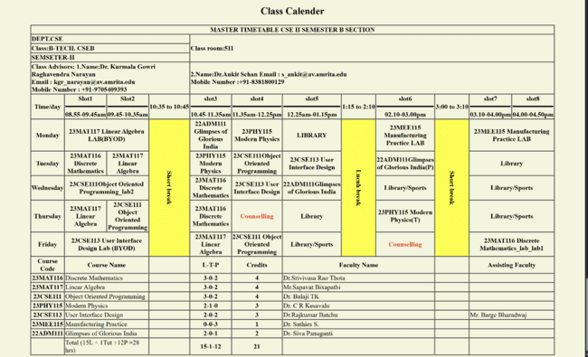

- Explanation:
- HTML-Hyper Text Markup Language.
- <DOCTYPE HTML>: Tells the browser about HTML version.
- <html>: Root element of an HTML page.
- <head>: Contains information about the HTML page.
- <title>: Specifies a title for the HTML page.
- <body>: Contains contents like images, links, etc.
- <h1> and <h2>: Defines heading .1 and 2 defines sizes.
- <pre>: defines preformatted text.
- style: style attribute for styling HTML elements.
- color: for text color.
- background-color: for background color.
- border: for border.
- align: for alignment.
- <img>: Defines an image.
- src: define the URL of the image
- width: define the size of the image
- <table>: Defines a table
- border-collapse: sets whether table borders should collapse
into a single border or be separated
- <tr>: Defines a row in a table
- <th>: Defines a header cell in a table
- <td>: Defines a cell in a table
- <br>: defines a line break.
- colspan: To make a cell span over multiple columns
- rowspan: To make a cell span over multiple rows

Week-4
- To understand the concept of forms and design a structured student registration form using HTML tables, including various input types such as text fields, radio buttons, checkboxes, file upload, and dropdown lists.
- Aim: To understand the concept of forms and design a structured student registration form using HTML tables, including various input types such as text fields, radio buttons, checkboxes, file upload, and dropdown lists.
- Program:
- Input:
- <!DOCTYPE html>
- <html style="background-color:bisque ;">
- <head>
- <title>Admission Form</title>
- </head>
- <boby>
- <h2 style="color:black;">
- <p style="text-align: center;">My name is CH. JAI RAM CHARAN,Roll no - 25106,Sec:CSE-B.</p>

- </h2>
- <table border="2" align="center" style="background-color:white;border-collapse: collapse;width:70%; height:500px;">
- <tr>
- <th colspan="2" style="background-color: aquamarine;">College Registration Form</th>
- </tr>
- <tr>
- <td>Full Name:</td>
- <td>
- <input type="text" placeholder="Full Name">
- </td>
- </tr>
- <tr>
- <td>Email:</td>
- <td>
- <input type="email" placeholder="Email"><br>
- </td>
- </tr>
- <tr>
- <td>Phone Number:</td>
- <td>
- <input type="tel" placeholder="Phone Number"><br>
- </td>
- </tr>
- <tr>
- <td>Gender:</td>
- <td>
- <form>
- <input type="radio" id="Male">
- <label for="Male">Male</label>
- <input type="radio" id="Female">
- <label for="Female">Female</label>
- <input type="radio" id="Others">
- <label for="Others">Others</label>
- </form>

- </td>
- </tr>
- <tr>
- <td>Course Applying For:</td>
- <td>
- <form>
- <select>
- <option value="B.Tech">B.Tech</option>
- <option value="M.Tceh">M.Tech</option>
- <option value="MBA">MBA</option>
- <option value="Phd">Phd</option>
- </select>
- </form>
- </td>
- </tr>
- <tr>
- <td>Hobbies:</td>
- <td>
- <input type="checkbox" id="Sports">
- <label for="Sports">Sports</label>
- <input type="checkbox" id="Music">
- <label for="Music">Music</label>
- <input type="checkbox" id="Reading">
- <label for="Reading">Reading</label>
- </td>
- </tr>
- <tr>
- <td>Date of Birth:</td>
- <td>
- <input type="date" id="D.O.B" name="D.O.B">
- </td>
- </tr>
- <tr>
- <td>Upload File:</td>
- <td>
- <input type="file">

- </td>
- </tr>
- <tr>
- <td>Address:</td>
- <td>
- <textarea rows="5" cols="25"></textarea>
- </td>
- </tr>
- <tr align="center">
- <td colspan="2">
- <input type="submit" value="Submit">
- <input type="reset" value="Reset">
- </td>
- </tr>
- </table>
- </boby>
- </html>

- Output:
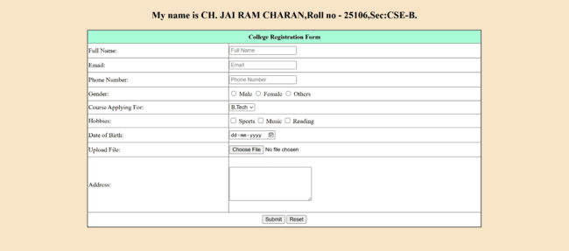
- Explanation:
- HTML-Hyper Text Markup Language.
- <DOCTYPE HTML>: Tells the browser about HTML version.
- <html>: Root element of an HTML page.
- <head>: Contains information about the HTML page.
- <title>: Specifies a title for the HTML page.
- <body>: Contains contents like images, links, etc.
- <h1> and <h2>: Defines heading .1 and 2 defines sizes.
- <p>: defines paragraph.
- style: style attribute for styling HTML elements.
- background-color: for background color.
- border: for border.
- align: for alignment.
- src: define the URL of the image
- width: define the size of the image
- <table>: Defines a table
- border-collapse: sets whether table borders should collapse
into a single border or be separated
- <tr>: Defines a row in a table
- <th>: Defines a header cell in a table
- <td>: Defines a cell in a table
- <br>: defines a line break.
- colspan: To make a cell span over multiple columns
- <input>: Defines an input control.
- <form>: Defines an HTML form for user input
- <textarea>: Defines a multiline input control (text area)
- <label>: Defines a label for an <input> element
- <select>: Defines a drop-down list
- <option>:Defines an option in a drop-down list
- value: specifies an initial value for an input field
- type: Specifies the input type to display
- for: is used inside the <label> tag to Connects a label to an
input field.
- id: gives a unique name to an HTML element.
- submit: defines a button for submitting .
- reset: defines a reset button
- rows and cols: specifies number of rows and columns.
- file: defines a file-select field
- date: is used for input fields that should contain a date
- checkbox:defines a checkbox.
- radio: defines a radio button
- tel: is used for input fields that should contain a telephone
number
- placeholder: specifies a short hint that describes the
expected value
- email: s used for input fields that should contain an e-mail
address
- text: defines a single-line text input field.
- A company wants to design a webpage that displays two different forms side by side using iframes.
- Aim: To design a webpage that displays two different forms side by side using iframes.
- Procedure:
- Input:
- <!DOCTYPE html>
- <html style="background-color:bisque;">
- <head>
- <title>Login and registration</title>
- </head>
- <boby>
- <h2>
- <p style="text-align: center;">My name is CH. JAI RAM CHARAN,Roll no - 25106,Sec:CSE-B.</p>
- </h2>
- <iframe src="iframe_1.html" height="500" width="49%"
- style="background-color: rgb(151, 151, 85);"></iframe>
- <iframe src="iframe_2.html" height="500" width="49%"align="right" style="background-color: rgb(151, 151, 85);"> </iframe>
- </boby>
- </html>

- <!DOCTYPE html>
- <html>
- <body>
- <h3 style="text-align: center;">User Login</h3>
- <table border="2" align="center" width="30%" height="150"
- style="border-collapse: collapse;background-color:white;">

- <td>Username:</td>
- <td>
- <input type="text"><br>
- </td>
- </tr>
- <tr>
- <td>Password:</td>
- <td>
- <input type="password"><br>
- </td>
- </tr>
- <tr>
- <td colspan="2" align="center">
- <input type="button" value="Login" align="center">
- </td>
- </tr>
- </table>
- </body>
- </html>
- <!DOCTYPE html>
- <html>
- <body>
- <h2 align="center">User Registration</h2>
- <table border="2" style="border-collapse:
- collapse;background-color:white;" align="center" width="50%"
- height="250">
- <tr>
- <td>Full Name:</td>
- <td>
- <input type="text" placeholder="Full Name"><br>
- </td>
- </tr>
- <tr>
- <td>Email:</td>

- <td>
- <input type="email" placeholder="Email"><br>
- </td>
- </tr>
- <tr>
- <td>Phone Number:</td>
- <td>
- <input type="tel" placeholder="Phone Number"><br>
- </td>
- </tr>
- <tr>
- <td>Password:</td>
- <td>
- <input type="password" placeholder="Password"><br>
- </td>
- </tr>
- <tr align="center">
- <td colspan="2">
- <input type="submit" value="Register">
- <input type="reset" value="Reset">
- </td>
- </tr>
- </table>
- </body>
- </html>

- Output:
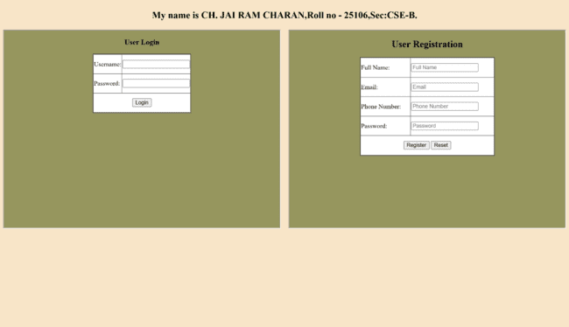

- Explanation:
- HTML-Hyper Text Markup Language.
- <DOCTYPE HTML>: Tells the browser about HTML version.
- <html>: Root element of an HTML page.
- <head>: Contains information about the HTML page.
- <title>: Specifies a title for the HTML page.
- <body>: Contains contents like images, links, etc.
- <h1> ,<h2>and <h3>: Defines heading .1,2 and 3 defines
sizes.
- <p>: defines paragraph.
- style: style attribute for styling HTML elements.
- background-color: for background color.
- border: for border.
- align: for alignment.
- src: define the URL of the image
- width and height: define the size of the image

- <iframe>: specifies an inline frame
- <table>: Defines a table
- border-collapse: sets whether table borders should collapse
into a single border or be separated
- <tr>: Defines a row in a table
- <td>: Defines a cell in a table
- <br>: defines a line break.
- colspan: To make a cell span over multiple columns
- <input>: Defines an input control.
- value: specifies an initial value for an input field
- type: Specifies the input type to display
- submit: defines a button for submitting .
- reset: defines a reset button
- tel: is used for input fields that should contain a telephone
number
- placeholder: specifies a short hint that describes the
expected value
- email: is used for input fields that should contain an e-mail
address
- text: defines a single-line text input field.
- password: defines a password field
- button: defines a button

Week_5
- To create a responsive card layout using HTML and CSS with three cards, each containing an image, title, and button.
- Aim: To create a responsive card layout using HTML and CSS with three cards, each containing an image, title, and button.
- Procedure:
- Input:
- <!DOCTYPE html>
- <html>
- <head>
- <title>responsive card layout</title>

- <style>
- .bodystyle{
- background-color:wheat;
- }
- .card-container{
- display:flex;
- gap:20px;
- justify-content:center;
- align-items: stretch;
- }
- .card{
- border:1px solid;
- border-color: black;
- text-align: center;
- align-items: center;
- display: flex;
- background-color:bisque;
- box-shadow: inset;
- border-radius: 5px;
- flex:1;
- flex-direction: column;

- }
- h1{
- text-align: center;
- border:solid black;
- border-radius: 5px;
- background-color: bisque;
- }
- h3{
- text-align:center;
- text-decoration: underline;
- }
- button{
- font-size: medium;
- background-color: rgb(249, 221, 117);
- border-radius:5px;
- margin-bottom: 5px;
- border:none;
- margin-top: auto;
- width: 200px;
- }
- button:hover{
- background-color:rgb(103, 170, 229);
- font-size:large;
- border-radius: 25px;
- }
- img{
- width:100%;
- height: 200px;
- object-fit: cover;
- }
- </style>
- </head>
- <body class="bodystyle">
- <p style="text-align: center;">My name is CH. JAI RAM CHARAN,Roll no - 25106,Sec:CSE-B.</p>
- <h1>Anime</h1>
- <div class="card-container">
- <div class="card">
- <img src="haikyu-1.jpg" alt="sloth_image">
- <h3>Haikyu</h3>
- <p>
- Haikyu!! (ハイキュー!!, Haikyū!!; from the kanji 排球, 'volleyball') is a Japanese manga series written and<br>
- illustrated by Haruichi Furudate.<br>
- It was serialized in Shueisha's shōnen manga magazine Weekly Shōnen Jump from February 2012 to July 2020,<br>
- with its chapters collected in 45 tankōbon volumes.<br>
- The story follows Shoyo Hinata, a boy determined to become a great volleyball player despite his small stature.<br>
- </p>
- <button type="button" onclick='location.href="https://en.wikipedia.org/wiki/Haikyu!!"'>About Haikyu</button>
- </div>
- <div class="card">
- <img src="jjk-1.jpg" alt="cat_image">
- <h3>JJK</h3>
- <p>
- Jujutsu Kaisen (呪術廻戦) is a Japanese manga series written and illustrated by Gege Akutami.<br>
- It was serialized in Shueisha's shōnen manga magazine Weekly Shōnen Jump from March 2018 to September 2024,<br>
- with its chapters collected in 30 tankōbon volumes.<br>
- The story follows high school student Yuji Itadori as he joins a secret organization of Jujutsu Sorcerers to<br>
- eliminate a powerful Curse named Ryomen Sukuna, of whom Yuji becomes the host.

- </p>
- <button type="button" onclick="location.href='https://en.wikipedia.org/wiki/Jujutsu_Kaisen'">About JJK</button>

- </div>
- <div class="card">
- <img src="onepiece-1.jpg" alt="sheep_image">
- <h3>OnePiece</h3>
- <p>
- One Piece is a Japanese manga series written and illustrated by Eiichiro Oda.<br>
- It follows the adventures of Monkey D. Luffy and his crew, the Straw Hat Pirates,<br>
- as he explores the Grand Line in search of the mythical treasure known as the "One Piece" to become the next King of the Pirates.

- </p>
- <button type="button" onclick="location.href='https://en.wikipedia.org/wiki/One_Piece'">About One Piece</button>

- </div>
- </div>

- </body>
- </html>

- Output:
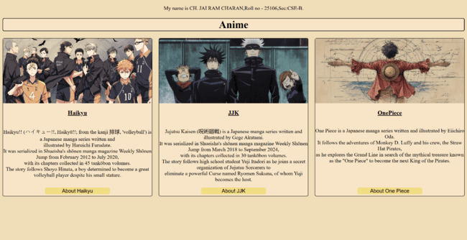
- Explanation:
- HTML-Hyper Text Markup Language.
- <DOCTYPE HTML>: Tells the browser about HTML version.
- <html>: Root element of an HTML page.
- <head>: Contains information about the HTML page.
- <title>: Specifies a title for the HTML page.
- <body>: Contains contents like images, links, etc.
- <h1> ,<h2>and <h3>: Defines heading .1,2 and 3 defines sizes.
- <p>: defines paragraph.
- style: style attribute for styling HTML elements.
- background-color: for background color.
- border: for border.
- align: for alignment.
- src: define the URL of the image
- width and height: define the size of the image
- “.”: class.
- text-align: position of text
- button: defines a button
- padding: sapce between margin and text
- div: defines a division or a section in an HTML document
- display:flex; Activates Flexbox layout
- flex-wrap:wrap; Allows items to move to the next line

- To design a mini website using iframe with navigation links (Home, About, Contact), where clicking on each link displays the respective content within the same page using internal or external CSS.

- Aim: To design a mini website using iframe with navigation links (Home, About, Contact), where clicking on each link displays the respective content within the same page using internal or external CSS.
- Procedure:
- Input:
- <!DOCTYPE html>
- <html>
- <head>
- <style>
- body
- {
- font-family: 'Times New Roman', Times, serif;
- background-image: url(wallpaper-5.jpg);
- background-size: cover;
- justify-items: center;
- color: rgb(132, 215, 104);
- font-size: xx-large;
- }
- iframe
- {
- width: 100%;
- height: 900px;
- border: none;
- }
- .link
- {
- display: inline;
- padding: 210px;
- font-size: 28px;
- color: rgb(132, 215, 104);
- }
- a{
- color:greenyellow
- }
- </style>
- </head>
- <body>
- <p style="text-align: center;">My name is CH. JAI RAM CHARAN,Roll no - 25106,Sec:CSE-B.</p>
- <div class="link">
- <a href="home.html" target="content">Home</a>
- </div>
- <div class="link">
- <a href="about.html" target="content">About</a>
- </div>
- <div class="link">
- <a href="contact.html" target="content">Contact</a>
- </div>

- <iframe name="content"></iframe>
- </body>
- </html>

- Home:
- <!DOCTYPE html>
- <html>
- <head>
- <style>
- h1{
- text-align: center;
- color: greenyellow;
- }
- h2{
- color: greenyellow;
- }
- body{
- background-image: url(jjk-1.jpg);
- font-size: larger;
- }
- pre{
- color: aquamarine;
- }
- a{
- color: greenyellow;
- }
- </style>
- </head>
- <body>
- <h1>MAPPA STUDIOS</h1>
- <h2>HOME</h2>
- <pre>
- Delivering anime that will always remain in the hearts of viewers

- What we consider most important are the fans who look forward to our works.
- Those fans who cry, laugh, and have their hearts touched by the stories we bring to life....
- Thinking of each and every face on the other side of the screen, we wish to create animation that makes them say to themselves, “I am glad I
- encountered this animation”, that makes them want to watch it over and over again.
- As a studio, we strive to deliver animation that will remain in the hearts and minds of our fans, while challenging new forms of expression and
- experimenting with various genres without focusing on any particular style.
- </pre>
- <a href="https://www.mappa.co.jp/en/">Web site link</a>
- </body>
- </html>

- About:
- <!DOCTYPE html>
- <html>
- <head>
- <style>
- h1{
- text-align: center;
- color: greenyellow;
- }
- h2{
- color: greenyellow;
- }
- body{
- background-image: url(jjk-1.jpg);
- font-size: larger;
- }
- pre{
- color: aquamarine;
- }
- </style>
- </head>
- <body>
- <h1>MAPPA STUDIOS</h1>
- <h2>ABOUT</h2>
- <pre>
- Company Name:MAPPA Co., LTD.
- Established:06/14/2011

- Management

- President : Manabu Otsuka
- Chairman of the Board of Directors : Masao Maruyama
- Executive Vice President : Hiroya Hasegawa
- Board Member : Yusuke Tannawa
- Board Member : Shuhei Yabuta
- Board Member : Kosuke Hosokai
- External Board Member : Yuichi Fukushima
- Executive Officer : Keisuke Seshimo
- Executive Officer : Motoi Okuno

- Chief Rights Officer : Eiji Matsuo

- Business Outline:
- With a focus on the production of TV animation, we plan and produce animated content across all genres and in a variety of other formats such as movies, commercials, and online videos.
- We also make use of the rights that we own for certain IPs as we operate our licensing business both domestically and overseas.
- Number of Employees:467
- </pre>
- </body>

- </html>

- Contact:
- <!DOCTYPE html>
- <html>
- <head>
- <style>
- h1{
- text-align: center;
- color: greenyellow;
- }
- h2{
- color: greenyellow;
- }
- body{
- background-image: url(jjk-1.jpg);
- font-size: larger;
- background-repeat: no-repeat;
- background-size: cover;
- }
- pre{
- color: aquamarine;
- }
- </style>

- </head>
- <body>
- <h1>MAPPA STUDIOS</h1>
- <h2>Contact</h2>
- <pre>
- Please feel free to contact us regarding work requests and consultations.
- Depending on the content of your inquiry, we may not be able to reply to you.
- We appreciate your understanding in advance.

- Contact
- info@mappa.co.jp

- </pre>
- </body>
- </html>

- Output:
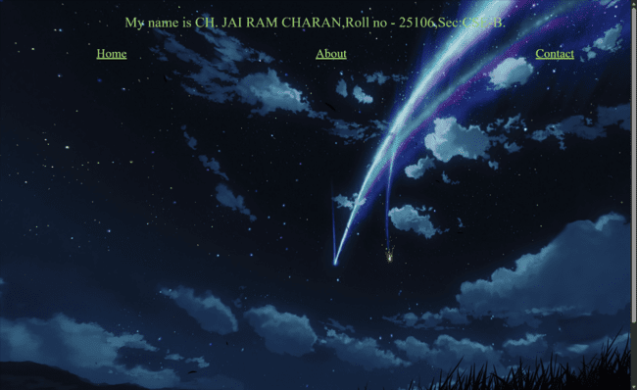

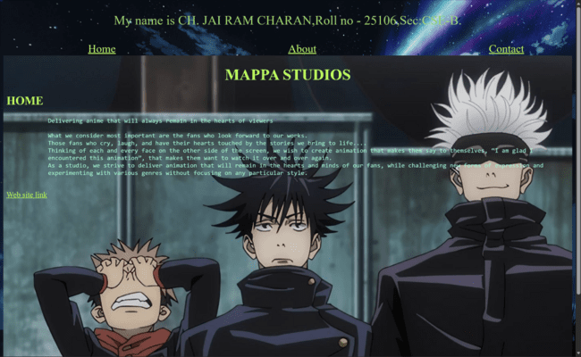

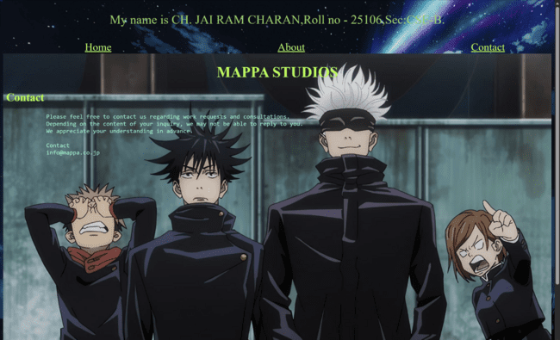
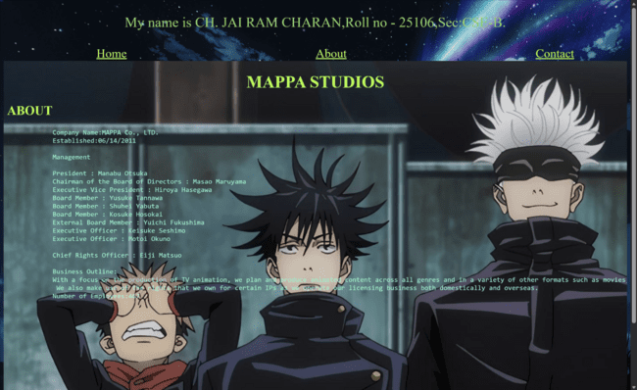

- Explanation:
- HTML-Hyper Text Markup Language.
- <DOCTYPE HTML>: Tells the browser about HTML version.
- <html>: Root element of an HTML page.
- <head>: Contains information about the HTML page.
- <title>: Specifies a title for the HTML page.
- <body>: Contains contents like images, links, etc.
- <h1> ,<h2>and <h3>: Defines heading .1,2 and 3 defines sizes.
- <p>: defines paragraph.
- style: style attribute for styling HTML elements.
- background-color: for background color.
- border: for border.
- align: for alignment.
- src: define the URL of the image
- width and height: define the size of the image
- “.”: defines class.
- text-align: position of text
- padding: sapce between margin and text
- <a>: The tag ‘<a>’ stands for ‘anchor’, used to define a hyperlink.
- <link>: Used to connect an external file to the HTML page (mostly CSS).
- <ifame>: Used to embed another webpage inside your webpage.
- name: Gives a name/identifier to an element.
- target: Defines where the linked document will open.
- rel: relationship between HTML and the file.
- href: location of the file.

- To design an Amrita login page using HTML and CSS that displays different campuses, where clicking on each campus shows its details on the same page.
- Aim: To design an Amrita login page using HTML and CSS that displays different campuses, where clicking on each campus shows its details on the same page.
- Procedure:
- Input:
- <!DOCTYPE html>
- <html>
- <head>
- <title>5c</title>
- <style>
- h1{
- color:red;
- text-align: center;
- }
- .container{
- display:flex;
- gap:50px;
- justify-content: center;
- }
- iframe{
- border:none;
- border-radius:10px;
- box-shadow:0px 0px 10px brown;
- background-color: lightcyan;

- }
- th{
- border:1px solid;
- border-radius: 5px;
- border-color: grey;
- padding-left:10px;
- padding-right: 10px;
- }
- a{
- text-decoration: none;
- font-size: larger;
- }
- a:hover{
- color:maroon
- }
- body{
- background-image: url(wallpaper-5.jpg);
- background-repeat: no-repeat;
- background-size: cover;
- }
- th{
- background-color: rgb(56, 205, 155);
- color: black;
- }
- </style>
- </head>
- <body>
- <h1>AMRITA VISHWA VIDYAPEETHAM</h1>
- <p style="text-align: center;color:red;font-size: large;">My name is CH. JAI RAM CHARAN,Roll no - 25106,Sec:CSE-B.</p>

- <table align="center" cellspacing="50">
- <tr>
- <th><a href="5c1.html" target="test1">Amaravati</a></th>
- <th><a href="5c2.html" target="test1">Amritapuri</a></th>
- <th><a href="5c3.html" target="test1">Coimbatore</a></th>
- <th><a href="5c4.html" target="test1">Nagercoil</a></th>
- <th><a href="5c5.html" target="test1">Faridabad</a></th>
- </tr>
- </table>
- <div class="container">
- <iframe src="login.html" width="400px" height="400px"></iframe>
- <iframe src="5c1.html" name="test1" title="test" width="400px" height="400px"></iframe>
- </div>

- </body>
- </html>

Login
- <!DOCTYPE html>
- <html>
- <body>
- <h1>Login</h1>
- <table>
- <form>
- <tr>
- <td>
- <label for="email">Email:</label>
- </td>
- <td>
- <input type="text" id="email" placeholder="Email">
- </td>
- </tr>
- <tr>
- <td>
- <label for="pass">Password:</label>
- </td>
- <td>
- <input type="text" id="pass" placeholder="Password">
- </td>
- </tr>
- <tr>
- <td>
- <input type="checkbox" value="Saveme">Save</input>
- </td>
- <td>
- <a href="">Forgot password?</a>
- </td>
- </tr>
- <tr>
- <td>
- <button type="button" onclick="alert('login successful')">Login</button>
- </td>
- </tr>
- <tr>
- <td>
- <p>Don't have a account?</p>
- </td>
- <td>
- <a href="">Register</a>
- </td>
- </tr>
- </form>
- </table>
- </body>
- </html>

<!DOCTYPE html>
<html>
<body>
<h1>About The Campus</h1>
<p>Amrita Vishwa Vidyapeetham is a leading multi-disciplinary and research-intensive university,<br>
establishing its campus in Amaravati.<br>
Nestled amidst the scenic beauty of the Krishna River and surrounded by natural wonders and historical sites,<br>
Amaravati city embodies the principles of sustainability and liveability.<br>
We are building one of the most buoyant centre of the research, education and technological advancement,<br>
in the all new greenfield capital city.</p>
<img src="amaravati.jpg" alt="amrita amaravati" width="100%">
</body>
</html>
<!DOCTYPE html>
<html>
<body>
<h1>About The Campus</h1>
<p>Amrita Vishwa Vidyapeetham's Amritapuri <br>
campus located in the pleasing village of <br>
Vallikavu is a multi-disciplinary research <br>
and teaching institute peacefully blended <br>
with science and spirituality</p>
<img src="amritapuri.jpg" alt="amrita amaravati">
</body>
</html>
<!DOCTYPE html>
<html>
<body>
<h1>About The Campus</h1>
<p>Amrita University's Coimbatore campus started<br>
in a hidden village named Ettimadai provides<br>
over 120 UG, PG and doctoral programs to a<br>
student population of over 12,000 and<br>
faculty strength of nearly 1500</p>
<img src="coimbatore.jpg" alt="amrita amaravati">

</body>
</html>
<!DOCTYPE html>
<html>
<body>
<h1>About The Campus</h1>
<p>Amrita Vishwa Vidyapeetham, situated in Erachakulam,<br>
Nagercoil is a beacon of educational excellence<br>
which operates under the esteemed Mata<br>
Amritanandamayi Math. Founded by Satguru<br>
Mata Amritanandamayi Devi (Amma), our institution<br>
is dedicated to providing holistic education,<br>
guided by Amma’s profound vision encapsulated<br>
in the philosophy of “Education for Life.”</p>
<img src="nagercoil.jpg" alt="amrita amaravati">

</body>
</html>
<!DOCTYPE html>
<html>
<body>
<h1>About The Campus</h1>
<p>A land that has witnessed the historical<br>
prominence of ultra-modern facilities in<br>
India. A place where science, technology,<br>
and research merge to embrace good health<br>
across a 130-acre sprawling health city campus.</p>
<img src="faridabad.jpg" alt="amrita amaravati" width="100%">

</body>
</html>

- Output:
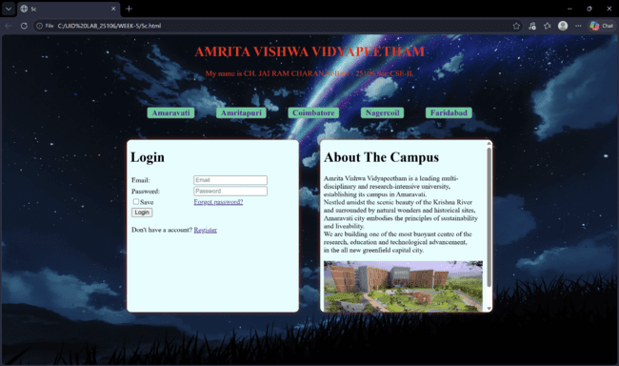
- Explanation:
- HTML-Hyper Text Markup Language.
- <DOCTYPE HTML>: Tells the browser about HTML version.
- <html>: Root element of an HTML page.
- <head>: Contains information about the HTML page.
- <title>: Specifies a title for the HTML page.
- <body>: Contains contents like images, links, etc.
- <h1> ,<h2>and <h3>: Defines heading .1,2 and 3 defines sizes.
- <p>: defines paragraph.
- style: style attribute for styling HTML elements.
- background-color: for background color.
- border: for border.
- align: for alignment.
- src: define the URL of the image
- width and height: define the size of the image
- “.”: defines class.
- text-align: position of text
- padding: sapce between margin and text
- <a>: The tag ‘<a>’ stands for ‘anchor’, used to define a hyperlink.
- <link>: Used to connect an external file to the HTML page (mostly CSS).
- <ifame>: Used to embed another webpage inside your webpage.
- name: Gives a name/identifier to an element.
- Target :Defines where the linked document will open.
- rel: relationship between HTML and the file
- href: location of the file
- <input>: Defines an input control.
- value: specifies an initial value for an input field
- type: Specifies the input type to display
- text: defines a single-line text input field.
- password: defines a password field
- button: defines a button
- placeholder: specifies a short hint that describes the expected value
- <label>: Defines a label for an <input> element
- div: defines a division or a section in an HTML document
- text-decoration: Used to add or remove decoration from text
- marign: Creates space outside an element
- text-transform: Changes the case of text.
- <img>: Used to display images in HTML
- box-shadow: Adds shadow around elements.
- backdrop-filter: Applies blur or visual effect to background behind an element.
- border-radius: Makes rounded corners
- line-height: Controls space between lines of text.

Week-6

- Design a responsive e-commerce application using the grid layout. This application should contain different categories of products such as electronics, clothing, home-appliances, books.
- Aim: Design a responsive e-commerce application using the grid layout. This application should contain different categories of products such as electronics, clothing, home-appliances, books.
- Procedure:
- Input:
- <!DOCTYPE html>
- <html>
- <head>
- <style>
- body{
- margin: 0;
- background-color:bisque;
- }
- .main{
- display: grid;
- grid-template-areas:
- "Header Header"
- "Sidebar Products"
- "Sidebar Products"
- "footer footer";
- gap: 15px;
- grid-template-columns:250px 1fr;
- }
- .header{
- grid-area:Header;
- background-color:lightseagreen;
- text-align: center;
- }
- .header h1{
- color: ghostwhite;
- }

- .sidebar{
- grid-area:Sidebar;
- height: auto;
- background-color: lightgoldenrodyellow;
- padding: 5px;
- }

- .sidebar h3{
- margin-bottom: 0;
- }
- .sidebar p{
- border-bottom: 1px solid rgb(161, 154, 154);
- padding: 10px;
- cursor: pointer;
- margin-top: 0;
- margin-bottom: 0;
- }
- .products{
- grid-area: Products;
- display: grid;
- grid-template-columns: repeat(2,1fr);
- gap: 20px;
- padding: 20px;
- }
- .card{
- box-shadow: 0px 0px 10px;
- background-color:lightblue;
- text-align: center;
- border-radius:10px;
- }
- .card img{
- width:200px;
- margin: 5px;

- }
- .card button{
- background:#2563EB;
- color:white;
- border:none;
- padding:8px 15px;
- border-radius:5px;
- cursor:pointer;
- }
- .card button:hover{
- background:#1D4ED8;
- }
- .footer{
- grid-area: footer;
- background-color:black;
- color:ghostwhite;
- text-align:center;
- padding:15px;
- }
- </style>
- </head>
- <body>
- <p style="text-align: center;color:red;font-size: large;">My name is CH. JAI RAM CHARAN,Roll no - 25106,Sec:CSE-B.</p>
- <div class="main">
- <div class="header">
- <h1>Anime Store</h1>
- </div>
- <div class="sidebar">
- <h3>Category</h3>
- <p>Manga</p>
- <p>Items</p>
- <p>Clothes</p>
- <p>Accessories</p>
- </div>
- <div class="products">
- <div class="card">
- <img src="one piece cover page.jpg">
- <h3>One Piece</h3>
- <p>$30</p>
- <button>Buy now</button>
- </div>
- <div class="card">
- <img src="demon slayer manga cover page.webp">
- <h3>Demon Slayer</h3>
- <p>$25</p>
- <button>Buy now</button>
- </div>
- <div class="card">
- <img src="jjk cover page.jpg">
- <h3>JJk</h3>
- <p>$28</p>
- <button>Buy now</button>
- </div>
- <div class="card">
- <img src="naruto cover page.jpg">
- <h3>Naruto</h3>
- <p>$24</p>
- <button>Buy now</button>
- </div>
- </div>
- <div class="footer">
- <p>© 2026 Anime Store | All Rights Reserved</p>
- </div>
- </div>
- </body>
- </html>

- Output:
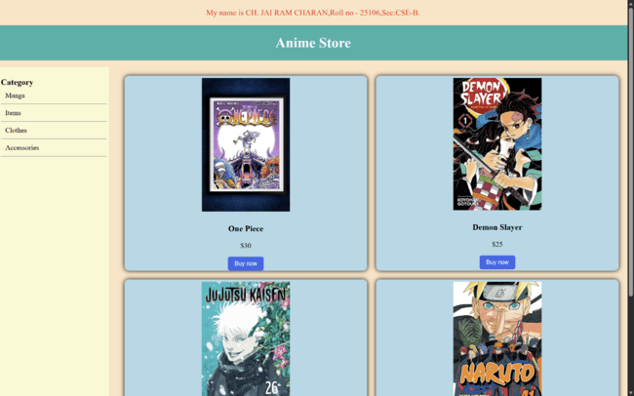
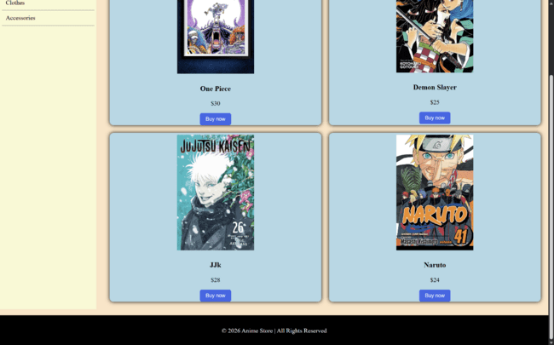

- Explanation:
- HTML-Hyper Text Markup Language.
- <DOCTYPE HTML>: Tells the browser about HTML version.
- <html>: Root element that contains the entire webpage
- <head>:Contains metadata and styles of the webpage
- <style>:Used to write CSS styling inside the HTML page
- <body>:Contains all visible content of the webpage
- <div>:Container used to group elements and apply styles
- <h1>:Main heading of the webpage
- <h3>:Sub-heading used for categories and details
- <p>:Defines paragraph text
- <img>:Displays an image on the webpage
- <button>: Creates a clickable button
- class: Connects HTML element with CSS styling
- src: Specifies the image file location
- margin: Creates space outside an element
- background-color: Sets the background color of an element
- display: Defines how elements are displayed (grid layout here)
- grid-template-areas: Defines the layout structure of grid sections
- gap: Creates space between grid items
- grid-template-columns: Defines number and width of columns in grid
- grid-area: Assigns an element to a specific grid area
- text-align: Aligns text (left, right, center)
- color: Sets the text color
- height: Defines the height of an element
- padding: Creates space inside an element
- margin-bottom: Adds space below an element
- margin-top: Adds space above an element
- border-bottom: Adds a bottom border line
- cursor: Changes cursor to pointer when hovering
- box-shadow: Adds shadow around elements
- border-radius: Creates rounded corners
- width: Sets the width of an image
- border: Removes or adds border around element
- hover: Changes style when mouse is over the element

- Design a responsive e-commerce application using the grid layout. This application should contain different categories of products such as electronics, clothing, home-appliances, books.
- Aim: Design a responsive e-commerce application using the grid layout. This application should contain different categories of products such as electronics, clothing, home-appliances, books.
- Procedure:
- Input:
- <!DOCTYPE html>
- <html>
- <head>
- <style>
- body{
- margin: 0;
- background-color: bisque;
- }
- .main{
- display: grid;
- grid-template-areas:
- "Header Header"
- "Sidebar Product"
- "Sidebar Product"
- "footer footer";
- gap: 15px;
- grid-template-columns:250px 1fr;
- }
- .header{
- grid-area:Header;
- background-color:#1F2937;
- text-align: center;
- }
- .header h1{
- color: lightseagreen;
- }

- .sidebar{
- grid-area:Sidebar;
- height: auto;
- background-color: lightgoldenrodyellow;
- padding: 5px;
- }

- .sidebar h3{
- margin-bottom: 0;
- }
- .sidebar p{
- border-bottom: 1px solid rgb(161, 154, 154);
- padding: 10px;
- cursor: pointer;
- margin-top: 0;
- margin-bottom: 0;
- }
- .sidebar a{
- text-decoration: none;
- color: black;
- }
- iframe{
- width: 100%;
- height: 730px;
- border: none;
- }
- .card{
- box-shadow: 0px 0px 10px;
- background-color: lightblue;
- text-align: center;
- border-radius:10px;
- }

- .card img{
- width:200px;
- margin: 5px;

- }
- .card button{
- background:#2563EB;
- color:white;
- border:none;
- padding:8px 15px;
- border-radius:5px;
- cursor:pointer;
- }
- .card button:hover{
- background:#1D4ED8;
- }
- .footer{
- grid-area: footer;
- background-color:black;
- color:ghostwhite;
- text-align:center;
- padding:15px;
- }
- </style>
- </head>
- <body>
- <p style="text-align: center;color:red;font-size: large;">My name is CH. JAI RAM CHARAN,Roll no - 25106,Sec:CSE-B.</p>
- <div class="main">
- <div class="header">
- <h1>Anime Store</h1>
- </div>
- <div class="sidebar">
- <h3>Category</h3>
- <p>
- <a href="manga.html" target="nav">Manga</a>
- </p>
- <p>
- <a href="items.html" target="nav">Items</a>
- </p>
- <p>
- <a href="clothes.html" target="nav">Clothes</a>
- </p>
- <p>
- <a href="accessories.html" target="nav">Accessories</a>
- </p>
- </div>
- <div>
- <iframe name="nav"></iframe>
- </div>
- <div class="footer">
- <p>© 2026 Electronics Store | All Rights Reserved</p>
- </div>
- </div>
- </body>
- </html>

Manga:
- <!DOCTYPE html>
- <html>
- <head>
- <style>
- .product{
- display:grid;
- grid-template-columns:repeat(2,1fr);
- gap:20px;
- padding:20px;
- }
- .card{
- box-shadow: 0px 0px 10px;
- background-color: lightblue;
- text-align: center;
- border-radius:10px;
- }
- .card img{
- width:200px;
- margin: 5px;
- }
- .card button{
- background:#2563EB;
- color:white;
- border:none;
- padding:8px 15px;
- border-radius:5px;
- cursor:pointer;
- }
- .card button:hover{
- background:bisque;
- }
- </style>
- </head>
- <body>
- <div class="product">
- <div class="card">
- <img src="one piece cover page.jpg">
- <h3>One Piece Manga</h3>
- <p>$30</p>
- <button>Buy now</button>
- </div>
- <div class="card">
- <img src="demon slayer manga cover page.webp">
- <h3>Demon Slayer Manga</h3>
- <p>$25</p>
- <button>Buy now</button>
- </div>
- <div class="card">
- <img src="jjk cover page.jpg" height="250px">
- <h3>JJk Manga</h3>
- <p>$28</p>
- <button>Buy now</button>
- </div>
- <div class="card">
- <img src="naruto cover page.jpg" height="270px">
- <h3>Naruto Manga</h3>
- <p>$24</p>
- <button>Buy now</button>
- </div>
- </div>
- </body>
- </html>

Items:
- <!DOCTYPE html>
- <html>
- <head>
- <style>
- .product{
- display:grid;
- grid-template-columns:repeat(2,1fr);
- gap:20px;
- padding:20px;
- }
- .card{
- box-shadow: 0px 0px 10px;
- background-color: lightblue;
- text-align: center;
- border-radius:10px;
- }
- .card img{
- width:200px;
- margin: 5px;
- }
- .card button{
- background:#2563EB;
- color:white;
- border:none;
- padding:8px 15px;
- border-radius:5px;
- cursor:pointer;
- }
- .card button:hover{
- background:bisque;
- }
- </style>
- </head>
- <body>
- <div class="product">
- <div class="card">
- <img src="one piece item - Copy.jpg">
- <h3>One Piece</h3>
- <p>$300</p>
- <button>Buy now</button>
- </div>
- <div class="card">
- <img src="demon slayer item.webp">
- <h3>Demon Slayer </h3>
- <p>$299</p>
- <button>Buy now</button>
- </div>
- <div class="card">
- <img src="jjk items.webp" height="250px">
- <h3>JJk </h3>
- <p>$199</p>
- <button>Buy now</button>
- </div>
- <div class="card">
- <img src="naruto item.webp" height="270px">
- <h3>Naruto</h3>
- <p>$240</p>
- <button>Buy now</button>
- </div>
- </div>
- </body>
- </html>

Clothes:
<!DOCTYPE html>
<html>
<head>
<style>
.product{
display:grid;
grid-template-columns:repeat(2,1fr);
gap:20px;
padding:20px;
}
.card{
box-shadow: 0px 0px 10px;
background-color: lightblue;
text-align: center;
border-radius:10px;
}
.card img{
width:200px;
margin: 5px;
}
.card button{
background:#2563EB;
color:white;
border:none;
padding:8px 15px;
border-radius:5px;
cursor:pointer;
}
.card button:hover{
background:bisque;
}
</style>
</head>
<body>
<div class="product">
<div class="card">
<img src="one piece clothes.jpg">
<h3>One Piece</h3>
<p>$200</p>
<button>Buy now</button>
</div>
<div class="card">
<img src="demon slayer clothes.webp">
<h3>Demon Slayer </h3>
<p>$199</p>
<button>Buy now</button>
</div>
<div class="card">
<img src="jjk clothes.webp" height="250px">
<h3>JJk </h3>
<p>$300</p>
<button>Buy now</button>
</div>
<div class="card">
<img src="naruto clothes.webp" height="270px">
<h3>Naruto</h3>
<p>$220</p>
<button>Buy now</button>
</div>
</div>
</body>
</html>

Accessories:

<!DOCTYPE html>
<html>
<head>
<style>
.product{
display:grid;
grid-template-columns:repeat(2,1fr);
gap:20px;
padding:20px;
}
.card{
box-shadow: 0px 0px 10px;
background-color: lightblue;
text-align: center;
border-radius:10px;
}
.card img{
width:200px;
margin: 5px;
}
.card button{
background:#2563EB;
color:white;
border:none;
padding:8px 15px;
border-radius:5px;
cursor:pointer;
}
.card button:hover{
background:bisque;
}
</style>
</head>
<body>
<div class="product">
<div class="card">
<img src="one piece accessories.webp">
<h3>One Piece</h3>
<p>$100</p>
<button>Buy now</button>
</div>
<div class="card">
<img src="demon slayer accessories.webp">
<h3>Demon Slayer </h3>
<p>$99</p>
<button>Buy now</button>
</div>
<div class="card">
<img src="jjk accessories.webp" height="250px">
<h3>JJk </h3>
<p>$110</p>
<button>Buy now</button>
</div>
<div class="card">
<img src="naruto accessories.webp" height="270px">
<h3>Naruto</h3>
<p>$150</p>
<button>Buy now</button>
</div>
</div>
</body>
</html>
- Output:
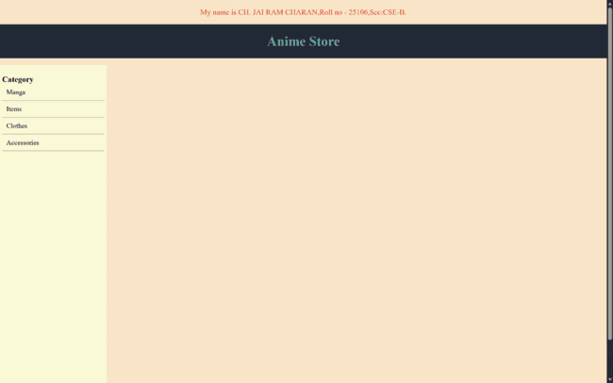
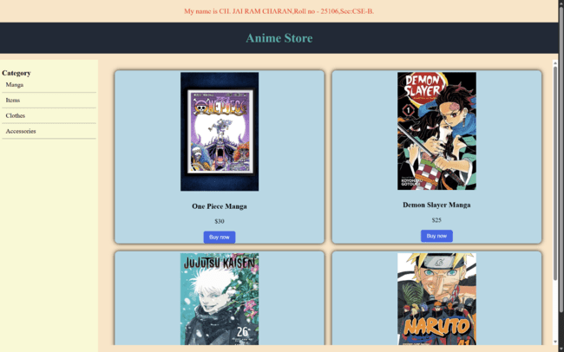
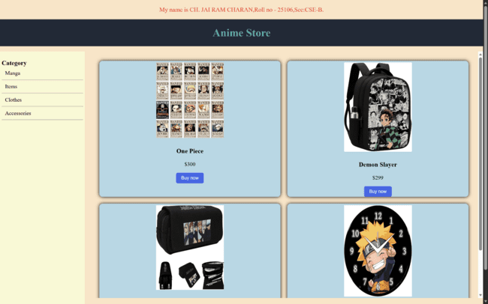
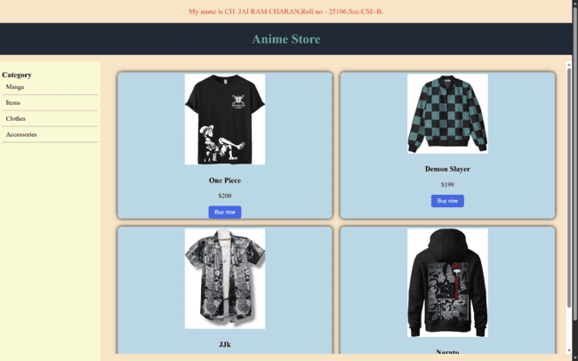
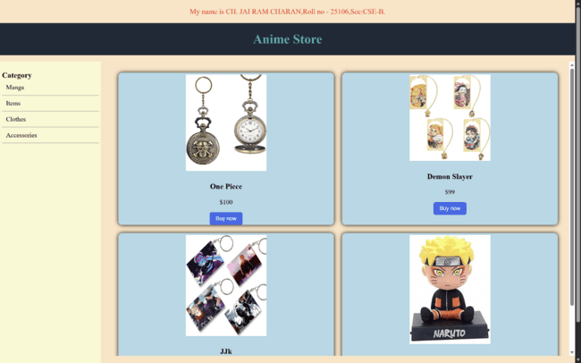

- Explanation:
- HTML-Hyper Text Markup Language.
- HTML-Hyper Text Markup Language.
- <DOCTYPE HTML>: Tells the browser about HTML version.
- <html>: Root element that contains the entire webpage
- <head>:Contains metadata and styles of the webpage
- <style>:Used to write CSS styling inside the HTML page
- <body>:Contains all visible content of the webpage
- <div>:Container used to group elements and apply styles
- <h1>:Main heading of the webpage
- <h3>:Sub-heading used for categories and details
- <p>:Defines paragraph text
- <img>:Displays an image on the webpage
- <button>: Creates a clickable button
- class: Connects HTML element with CSS styling
- src: Specifies the image file location
- margin: Creates space outside an element
- background-color: Sets the background color of an element
- display: Defines how elements are displayed (grid layout here)
- grid-template-areas: Defines the layout structure of grid sections
- gap: Creates space between grid items
- grid-template-columns: Defines number and width of columns in grid
- grid-area: Assigns an element to a specific grid area
- text-align: Aligns text (left, right, center)
- color: Sets the text color
- height: Defines the height of an element
- padding: Creates space inside an element
- margin-bottom: Adds space below an element
- margin-top: Adds space above an element
- border-bottom: Adds a bottom border line
- cursor: Changes cursor to pointer when hovering
- box-shadow: Adds shadow around elements
- border-radius: Creates rounded corners
- width: Sets the width of an image
- border: Removes or adds border around element
- hover: Changes style when mouse is over the element
- <iframe>: Used to embed another webpage inside the current webpage
- target: Specifies where the linked page should open
- name: Gives a name to an element
- <a>: Used to create hyperlinks

Week-7
- Create a github account and create a repository named UIDLAB-CSE25106 and upload every week experiments, lab report in that repository and make the repository private.
Aim:
Create a github account and create a repository named UIDLAB-CSE25106 and upload every week experiments, lab report in that repository and make the repository private.
Step-1:
Create a github account by entering mailid , username, password,

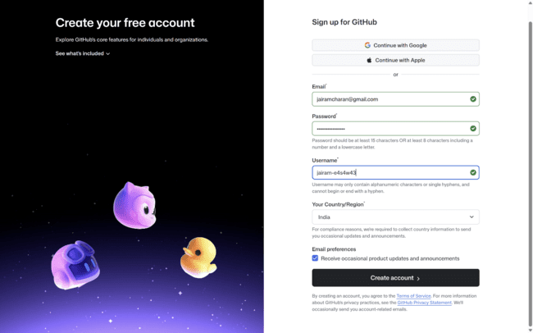

Step2:
Crete a repository by putting it on private with UIDLAB-rollno as name

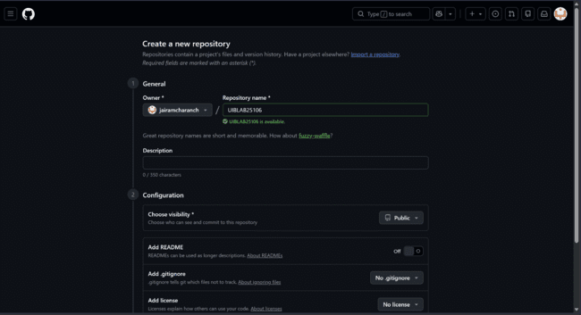

Step-3:
Click on upload files and upload the files of every week by selecting and dragging the entire folder.
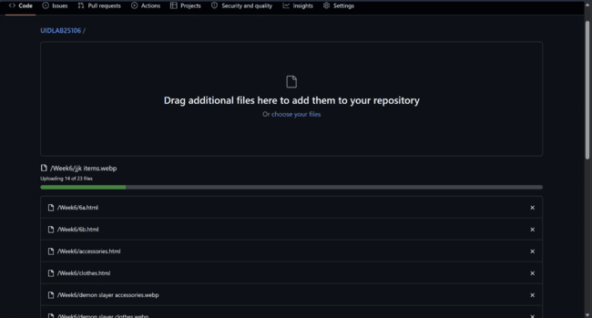
Step-4
Now click on commit changes to add all these files in the repository.
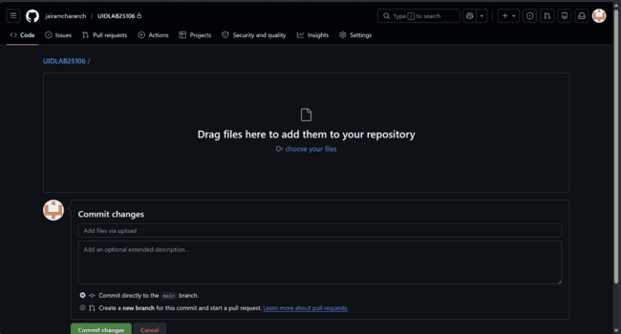
Step-5:
The added files will appear in that repository. If the folders are added them files can be accessed by clicking on the folder name.
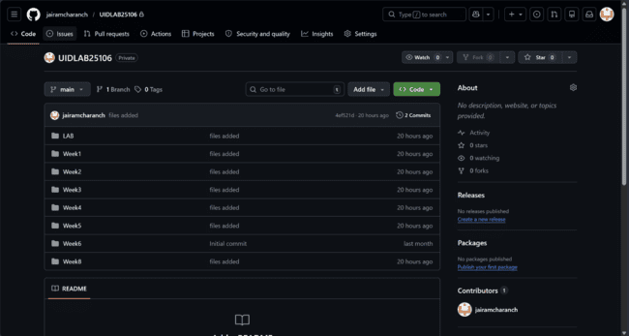

Week-8
- Create a webpage that displays a square that continuously rotates 360 using CSS.
- Aim: Create a webpage that displays a square that continuously rotates 360 using css.
- Procedure:
- Input:
- <!DOCTYPE html>
- <html>
- <head>
- <title>8a</title>
- <style>
- body{
- display: flex;
- flex-direction: column;
- align-items: center;
- justify-content: center;
- background-color:wheat;
- }
- .square{
- width:100px;
- height:100px;
- background-color:brown;
- position:relative;
- border-radius: 5px;
- animation: squareani;
- animation-duration:4s;
- animation-iteration-count: infinite;
- animation-timing-function: linear;
- box-shadow: 0 0 5px;
- margin-top: 100px;
- }
- @keyframes squareani{
- from{transfrom : rotate(0deg);}
- to{transform: rotate(360deg);}
- }
- </style>
- </head>
- <body>
- <p style="text-align: center;color:red;font-size: large;">My name is CH. JAI RAM CHARAN,Roll no - 25106,Sec:CSE-B.</p>
- <div class="container">
- <div class="square"></div>
- </div>

- </body>
- </html>
- Output:


- Explanation:
- HTML-Hyper Text Markup Language.
- <DOCTYPE HTML>: Tells the browser about HTML version.
- <html>: Root element that contains the entire webpage
- <head>:Contains metadata and styles of the webpage
- <style>:Used to write CSS styling inside the HTML page
- <body>:Contains all visible content of the webpage
- <div>:Container used to group elements and apply styles
- <h1>:Main heading of the webpage
- <h3>:Sub-heading used for categories and details
- <p>:Defines paragraph text
- background-color: Sets the background color of an element
- transform: rotate() performs rotation
- @keyframes : defines motion
- rotate(0deg → 360deg): Starts from normal position to ends after full rotation (circle)
- width / height :Size of square
- position: relative : Positioned relative to itself
- animation-duration : It defines how long an animation should take to complete.
- animation-iteration-count property: It specifies the number of times an animation should run.
- animation-timing-function: This property specifies the speed curve of the animation.

- Create a ball that moves up and down continuously using CSS animation.
- Aim: Create a ball that moves up and down continuously using CSS animation.
- Procedure:
- Input:
- <!DOCTYPE html>
- <html>
- <head>
- <title>8b</title>
- <style>
- body{
- display: flex;
- flex-direction: column;
- align-items: center;
- justify-content: center;
- background-color:wheat;
- }
- .ball{
- width:100px;
- height:100px;
- background-color:brown;
- position:absolute;
- border-radius: 50%;
- animation: animation1;
- animation-duration:3s;
- animation-delay: 1s;
- animation-iteration-count: infinite;
- animation-timing-function: linear;
- box-shadow: 0 0 5px;
- margin-top: 200px;
- }
- @keyframes animation1{
- 0%{transform : translateY(0px)}
- 25%{transform : translateY(-200px)}
- 50%{transform : translateY(0px)}
- 75%{transform: translateY(200px)}
- 100%{transform :translateY(0px)}
- }
- </style>
- </head>
- <body>
- <p style="text-align: center;color:red;font-size: large;">My name is CH. JAI RAM CHARAN,Roll no - 25106,Sec:CSE-B.</p>
- <div class="container">
- <div class="ball"></div>
- </div>

- </body>
- </html>

- Output:
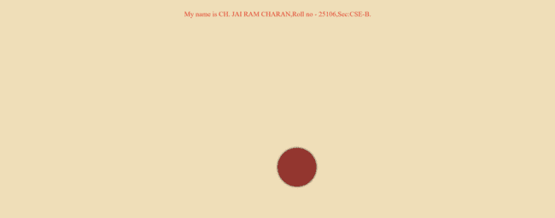

- Explanation:
- HTML-Hyper Text Markup Language.
- <DOCTYPE HTML>: Tells the browser about HTML version.
- <html>: Root element that contains the entire webpage
- <head>:Contains metadata and styles of the webpage
- <style>:Used to write CSS styling inside the HTML page
- <body>:Contains all visible content of the webpage
- <div>:Container used to group elements and apply styles
- <h1>:Main heading of the webpage
- <h3>:Sub-heading used for categories and details
- <p>:Defines paragraph text
- background-color: Sets the background color of an element
- transform: rotate() performs rotation
- @keyframes : defines motion
- rotate(0deg → 360deg): Starts from normal position to ends after full rotation (circle)
- width / height :Size of square
- position: relative : Positioned relative to itself
- animation-duration : It defines how long an animation should take to complete.
- animation-iteration-count property: It specifies the number of times an animation should run.
- animation-timing-function: This property specifies the speed curve of the animation.

- Create a circle that moves horizontally and rotates at the same time.
- Aim: Create a circle that moves horizontally and rotates at the same time.
- Procedure:
- Input:
- <!DOCTYPE html>
- <html>
- <head>
- <title>8b</title>
- <style>
- body{
- display: flex;
- flex-direction: column;
- align-items: center;
- justify-content: center;
- background-color: wheat;
- }
- .ball{
- width:100px;
- height:100px;
- background:linear-gradient(100deg,maroon,brown);
- border:1px solid black;
- position:absolute;
- border-radius: 50%;
- animation: animation1;
- animation-duration:5s;
- animation-delay: 1s;
- animation-iteration-count: infinite;
- animation-timing-function: linear;
- }
- @keyframes animation1{
- 0%{transform : translateX(0px) rotate(0deg)}
- 25%{transform : translateX(-200px) rotate(360deg)}
- 50%{transform : translateX(0px) rotate(720deg)}
- 75%{transform: translateX(200px) rotate(1080deg)}
- 100%{transform :translateX(0px) rotate(1460deg)}
- }

- </style>
- </head>
- <body>
- <p style="text-align: center;color:red;font-size: large;">My name is CH. JAI RAM CHARAN,Roll no - 25106,Sec:CSE-B.</p>
- <div class="container">
- <div class="ball"></div>
- </div>

- </body>
- </html>

- Output:

- Explanation:
- HTML-Hyper Text Markup Language.
- <DOCTYPE HTML>: Tells the browser about HTML version.
- <html>: Root element that contains the entire webpage
- <head>:Contains metadata and styles of the webpage
- <style>:Used to write CSS styling inside the HTML page
- <body>:Contains all visible content of the webpage
- <div>:Container used to group elements and apply styles
- <h1>:Main heading of the webpage
- <h3>:Sub-heading used for categories and details
- <p>:Defines paragraph text
- background-color: Sets the background color of an element
- transform: rotate() performs rotation
- @keyframes : defines motion
- rotate(0deg → 360deg): Starts from normal position to ends after full rotation (circle)
- position: relative : Positioned relative to itself
- animation-duration : It defines how long an animation should take to complete.
- animation-iteration-count property: It specifies the number of times an animation should run.
- animation-timing-function: This property specifies the speed curve of the animation.

Week-9
- A1. Write a JavaScript program to determine if a number is even or odd
A2. Write a JavaScript program to determine if a number is prime or not.
A3. Write a JavaScript program to find the factorial of a given number.
A4. Write a JavaScript program to determine if a number is Armstrong or not.
- Aim: A1. Write a JavaScript program to determine if a number is even or odd
A2. Write a JavaScript program to determine if a number is prime or not.
A3. Write a JavaScript program to find the factorial of a given number.
A4. Write a JavaScript program to determine if a number is Armstrong or not.
- Procedure:
- Input:
- <!DOCTYPE html>
- <html>
- <head>
- <title>9a</title>
- <style>
- body{
- background-color: bisque;
- }
- .container{
- display:grid;
- grid-template-areas:
- "header header"
- "frame1 frame2"
- "frame3 frame4";
- grid-template-rows: auto 1fr 1fr auto;
- grid-template-columns:1fr 1fr ;
- gap:20px;
- }
- .header{
- grid-area: header;
- text-align: center;
- background-color: wheat;
- border-radius: 10px;
- margin-left: 40px;
- margin-right: 50px;
- box-shadow: 0 0 10px rgba(0, 0, 0, 0.5);
- }
- .frame1{
- grid-area:frame1;
- background-color: wheat;
- max-width: 500px;
- min-height: 100px;
- text-align: center;
- justify-content: center;
- border-radius: 10px;
- margin-left: 50px;
- box-shadow: 0 0 10px rgba(0, 0, 0, 0.5);
- }
- .frame2{
- grid-area:frame2;
- background-color: wheat;
- max-width: 500px;
- min-height: 100px;
- text-align: center;
- justify-content: center;
- border-radius: 10px;
- margin-left: 50px;
- box-shadow: 0 0 10px rgba(0, 0, 0, 0.5);
- }
- .frame3{
- grid-area:frame3;
- background-color:wheat;
- max-width: 500px;
- min-height: 100px;
- text-align: center;
- justify-content: center;
- border-radius: 10px;
- margin-left: 50px;
- box-shadow: 0 0 10px rgba(0, 0, 0, 0.5);
- }
- .frame4{
- grid-area:frame4;
- background-color: wheat;
- max-width: 500px;
- min-height: 100px;
- text-align: center;
- justify-content: center;
- border-radius: 10px;
- margin-left: 50px;
- box-shadow: 0 0 10px rgba(0, 0, 0, 0.5);
- }
- button{
- margin-bottom: 10px;
- border:none;
- font-size: large;
- background-color: wheat;
- box-shadow: 0 0 5px rgba(0, 0, 0, 0.3);
- border-radius: 3px;;
- }
- button:hover{
- background-color: wheat;
- box-shadow: 0 0 8px rgba(0, 0, 0, 0.5);
- transform: scale(1.02)

- }
- </style>
- </head>
- <body>
- <p style="text-align: center;color:red;font-size: large;">My name is CH. JAI RAM CHARAN,Roll no - 25106,Sec:CSE-B.</p>
- <script>
- function even_odd(){
- const x= document.getElementById('even').value;
- const display = document.getElementById('res_1')
- const y = parseInt(x);
- if (y%2===0){
- display.innerHTML = y + " Is even";
- }
- else{
- display.innerHTML = y + " Is odd";
- }
- }
- function factorial(){
- const x= document.getElementById('fac').value;
- const display = document.getElementById('res_2')
- const y = parseInt(x);
- var fact=1;
- for(var i=1;i<=x;i++){
- fact*=i;
- }
- display.innerHTML="Factorial of the number is: " + fact

- }
- function prime(){
- const x= document.getElementById('pri').value;
- const display = document.getElementById('res_3');
- const y = parseInt(x);

- let isPrime = true;

- for(let i = 2; i <= Math.sqrt(y);i++){
- if(y%1 === 0){
- isPrime = false;
- break;
- }
- }
- if(isPrime){
- display.innerHTML = y + " Is a Prime Number";
- }
- else{
- display.innerHTML = y + " Is not a Prime Number";
- }
- }
- function amstrong(){
- const x= document.getElementById('ang').value;
- const display = document.getElementById('res_4')
- const y = parseInt(x);
- var sum=0;
- var temp=y;

- const dig = x.length;

- while(temp>0){
- let rem = temp%10;
- sum += Math.pow(rem,dig);
- temp = Math.floor(temp/10);
- }
- if(sum===y){
- display.innerHTML = y + " Is an arsmtrong number"
- }
- else{
- display.innerHTML = y + " Is not an arsmtrong number"
- }
- }
- </script>
- <div class="container">
- <div class="header"><h1>Javascript Applications</h1></div>
- <div class="frame1">
- <h3>Check even or odd</h3>
- <input type="number" id="even">
- <button onclick="even_odd()">Even or Odd</button>
- <p id="res_1">The result is</p>
- </div>
- <div class="frame2">
- <h3>Check factorial</h3>
- <input type="number" id="fac">
- <button onclick="factorial()">Find factorial</button>
- <p id="res_2">The factorial of the number is </p>
- </div>
- <div class="frame3">
- <h3>Check Prime or Not</h3>
- <input type="number" id="pri">
- <button onclick="prime()">Prime or not</button>
- <p id="res_3">The result is</p>
- </div>
- <div class="frame4">
- <h3>Check Armstrong Number</h3>
- <input type="number" id="ang">
- <button onclick="amstrong()">Armstrong or not</button>
- <p id="res_4">The result is</p>
- </div>

- </div>

- </body>
- </html>

- Output:

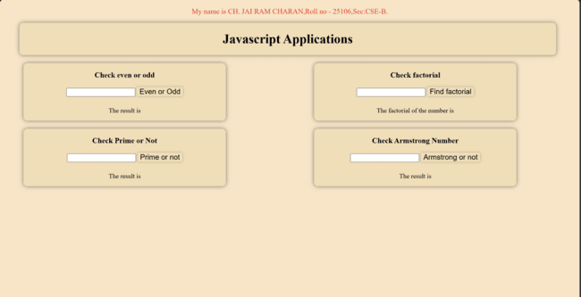
- Explanation:
- HTML-Hyper Text Markup Language.
- <DOCTYPE HTML>: Tells the browser about HTML version.
- <html>: Root element that contains the entire webpage
- <head>:Contains metadata and styles of the webpage
- <style>:Used to write CSS styling inside the HTML page
- <body>:Contains all visible content of the webpage
- <div>:Container used to group elements and apply styles
- <h1>:Main heading of the webpage
- <p>:Defines paragraph text
- background-color: Sets the background color of an element
- display: grid – This is used to create a layout system. It allows us to divide the page into rows and columns, making it easy to place different sections like the header, frames, and footer in required places.
- parseInt() – In the JavaScript part, this function is used to take the text typed in the input box and convert it into a integer.
- innerHTML – This property is used to change the content of an HTML element.
- document.getElementById("id") – This is the way JavaScript finds a specific element on the HTML page.
- Variables (var) – These are like small storage containers used to hold data.
- The javascript must be written inside <script></script> tags
- Javascript can be written in either head or body.
- Function – allows to create reusable code that can execute when called.

Week-10

- Write a JavaScript conditional statement to find the sign of product of three numbers using functions .Display an alert box with the specified sign.
- Aim: To Write a JavaScript conditional statement to find the sign of product of three numbers using functions .Display an alert box with the specified sign.
- Procedure:
- Input:
- <!DOCTYPE html>
- <html>
- <head>
- <title>Sign of Product</title>
- <style>
- body{
- background-color: bisque;
- }
- form {
- background-color: wheat;
- padding: 20px;
- margin: auto;
- width: 300px;
- border-radius: 10px;
- }
- </style>
- <script>
- function findSign() {
- let a = parseInt(prompt("Enter first number:"));
- let b = parseInt(prompt("Enter second number:"));
- let c = parseInt(prompt("Enter third number:"));

- let product = a * b * c;

- if (product > 0) {
- alert("The sign is + (Positive)");
- }
- else if (product < 0) {
- alert("The sign is - (Negative)");
- }
- else {
- alert("The product is 0");
- }
- }
- </script>
- </head>
- <body>
- <p style="text-align: center;color:red;font-size: large;">My name is CH. JAI RAM CHARAN,Roll no - 25106,Sec:CSE-B.</p>
- <form>
- <h2>Find Sign of Product</h2>
- <button onclick="findSign()">Enter Numbers</button>
- </form>
- </body>
- </html>

- Output:


- Explanation:
- HTML-Hyper Text Markup Language.
- <DOCTYPE HTML>: Tells the browser about HTML version.
- <html>: Root element that contains the entire webpage
- <head>:Contains metadata and styles of the webpage
- <style>:Used to write CSS styling inside the HTML page
- <body>:Contains all visible content of the webpage
- <div>:Container used to group elements and apply styles
- <h1>:Main heading of the webpage
- <h3>:Sub-heading used for categories and details
- <p>:Defines paragraph text
- background-color: Sets the background color of an element
- The javascript must be written inside <script></script> tags
- Javascript can be written in either head or body.
- Function – allows to create reusable code that can execute when called.
- prompt() → Opens an input box.
- User enters a number.
- parseInt() → Converts the entered text into an integer number.
- let a → Stores the value in variable a.

- Write a JavaScript conditional statement to sort three numbers using functions .Display an alert box to show the result.
- Aim: TO Write a JavaScript conditional statement to sort three numbers using functions .Display an alert box to show the result.
- Procedure:
- Input:
- <!DOCTYPE html>
- <html>
- <head>
- <title>Sort Three Numbers</title>
- <style>
- body{
- background-color: bisque;
- }
- form {
- background-color: wheat;
- padding: 20px;
- margin: auto;
- width: 300px;
- border-radius: 10px;
- }
- </style>
- <script>
- function sortNumbers() {
- let a = parseInt(prompt("Enter first number:"));
- let b = parseInt(prompt("Enter second number:"));
- let c = parseInt(prompt("Enter third number:"));

- let temp;

- if (a > b) {
- temp = a;
- a = b;
- b = temp;
- }

- if (a > c) {
- temp = a;
- a = c;
- c = temp;
- }

- if (b > c) {
- temp = b;
- b = c;
- c = temp;
- }

- alert("Sorted numbers: " + a + ", " + b + ", " + c);
- }
- </script>
- </head>
- <body>
- <p style="text-align: center;color:red;font-size: large;">My name is CH. JAI RAM CHARAN,Roll no - 25106,Sec:CSE-B.</p>
- <form>
- <h2>Find the Sorted List</h2>
- <button onclick="sortNumbers()">Sort Numbers</button>
- </form>
- </body>
- </html>

- Output:


- Explanation:
- HTML-Hyper Text Markup Language.
- <DOCTYPE HTML>: Tells the browser about HTML version.
- <html>: Root element that contains the entire webpage
- <head>:Contains metadata and styles of the webpage
- <style>:Used to write CSS styling inside the HTML page
- <body>:Contains all visible content of the webpage
- <div>:Container used to group elements and apply styles
- <h1>:Main heading of the webpage
- <h3>:Sub-heading used for categories and details
- <p>:Defines paragraph text
- background-color: Sets the background color of an element
- The javascript must be written inside <script></script> tags
- Javascript can be written in either head or body.
- Function – allows to create reusable code that can execute when called.
- prompt() → Opens an input box.
- User enters a number.
- parseInt() → Converts the entered text into an integer number.
- let a → Stores the value in variable a.

- Write a JavaScript conditional statement to find the largest of five numbers using function and onclick event .Display an alert box to show the result.
- Aim: To Write a JavaScript conditional statement to find the largest of five numbers using function and onclick event .Display an alert box to show the result.
- Procedure:
- Input:
- <!DOCTYPE html>
- <html>
- <head>
- <title>Largest of 5 Numbers</title>
- <style>
- body{
- background-color: bisque;
- }
- form {
- background-color: wheat;
- padding: 20px;
- margin: auto;
- width: 300px;
- border-radius: 10px;
- }
- </style>
- <script>
- function findLargest() {
- let n1 = parseFloat(document.getElementById("num1").value);
- let n2 = parseFloat(document.getElementById("num2").value);
- let n3 = parseFloat(document.getElementById("num3").value);
- let n4 = parseFloat(document.getElementById("num4").value);
- let n5 = parseFloat(document.getElementById("num5").value);

- let largest = n1;

- if (n2 > largest) largest = n2;
- if (n3 > largest) largest = n3;
- if (n4 > largest) largest = n4;
- if (n5 > largest) largest = n5;

- alert("The largest number is: " + largest);
- }
- </script>
- </head>
- <body>
- <p style="text-align: center;color:red;font-size: large;">My name is CH. JAI RAM CHARAN,Roll no - 25106,Sec:CSE-B.</p>
- <form>
- <h2>Find Largest of 5 Numbers</h2>

- Enter Number 1: <input type="text" id="num1"><br><br>
- Enter Number 2: <input type="text" id="num2"><br><br>
- Enter Number 3: <input type="text" id="num3"><br><br>
- Enter Number 4: <input type="text" id="num4"><br><br>
- Enter Number 5: <input type="text" id="num5"><br><br>

- <button onclick="findLargest()">Find Largest</button>
- </form>
- </body>
- </html>

- Output:


- Explanation:
- HTML-Hyper Text Markup Language.
- <DOCTYPE HTML>: Tells the browser about HTML version.
- <html>: Root element that contains the entire webpage
- <head>:Contains metadata and styles of the webpage
- <style>:Used to write CSS styling inside the HTML page
- <body>:Contains all visible content of the webpage
- <div>:Container used to group elements and apply styles
- <h1>:Main heading of the webpage
- <h3>:Sub-heading used for categories and details
- <p>:Defines paragraph text
- background-color: Sets the background color of an element
- The javascript must be written inside <script></script> tags
- Javascript can be written in either head or body.
- Function – allows to create reusable code that can execute when called.
- prompt() → Opens an input box.
- User enters a number.
- parseInt() → Converts the entered text into an integer number.
- let a → Stores the value in variable a.

- Write a JavaScript for loop that will iterate from 0 to 15. For each iteration, it will check if the current number is odd or even, and display a message to the screen.
- Aim: To Write a JavaScript for loop that will iterate from 0 to 15. For each iteration, it will check if the current number is odd or even, and display a message to the screen.
- Procedure:
- Input:
- <!DOCTYPE html>
- <html lang="en">
- <head>
- <style>
- body{
- background-color: bisque;
- max-width: 500px;
- margin: 40px auto;
- padding: 15px;
- text-align: center;
- border: solid white 2px;
- border-radius: 20px;
- color: red;
- font-weight: bold;
- font-family: Arial, Helvetica, sans-serif;
- }
- </style>
- </head>
- <body>
- <p style="text-align: center;color:red;font-size: large;">My name is CH. JAI RAM CHARAN,Roll no - 25106,Sec:CSE-B.</p>
- <script>
- for(let i=0;i<=15;i++){
- if(i==0){
- document.write(i+" is zero");
- }
- else if(i%2==0){
- document.write(i+" is even")
- }
- else{
- document.write(i+" is odd");
- }
- document.write("<br>")
- document.write("<br>")
- }
- </script>
- </body>
- </html>

- Output:
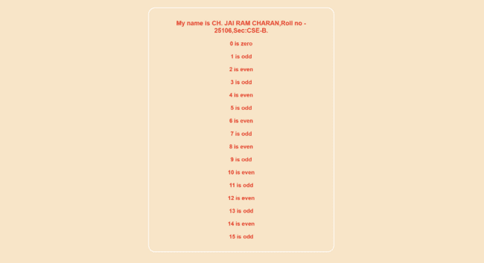

- Explanation:
- HTML-Hyper Text Markup Language.
- <DOCTYPE HTML>: Tells the browser about HTML version.
- <html>: Root element that contains the entire webpage
- <head>:Contains metadata and styles of the webpage
- <style>:Used to write CSS styling inside the HTML page
- <body>:Contains all visible content of the webpage
- <div>:Container used to group elements and apply styles
- <h1>:Main heading of the webpage
- <h3>:Sub-heading used for categories and details
- <p>:Defines paragraph text
- background-color: Sets the background color of an element
- The javascript must be written inside <script></script> tags
- Javascript can be written in either head or body.
- parseInt() → Converts the entered text into an integer number.
- document.write : Writens the value.
- For loop is used in the code.

- Write a JavaScript program which iterates the integers from 1 to 100. But for multiples of three print “LOL" instead of the number and for the multiples of five print “OK". For numbers which are multiples of both three and five print “LOL-OK".
- Aim: To Write a JavaScript program which iterates the integers from 1 to 100. But for multiples of three print “LOL" instead of the number and for the multiples of five print “OK". For numbers which are multiples of both three and five print “LOL-OK".
- Procedure:
- Input:
- <!DOCTYPE html>
- <html>
- <head>
- <style>
- body{
- max-width: 400px;
- text-align: center;
- margin:0px auto;
- background-color: bisque;
- color: red;
- font-size: large;
- }
- </style>
- </head>
- <body>
- <p style="text-align: center;color:red;font-size: large;">My name is CH. JAI RAM CHARAN,Roll no - 25106,Sec:CSE-B.</p>
- <script>
- for(let i=0;i<=100;i++){
- if(i%3==0 && i%5!=0){
- document.write("LOL");
- }
- else if(i%5==0 && i%3!=0){
- document.write("OK");
- }
- else if(i%3==0 && i%5==0){
- document.write("LOL-OK");
- }
- else{
- document.write(i);
- }
- document.write("<br>")
- }
- </script>
- </body>
- </html>

- Output:
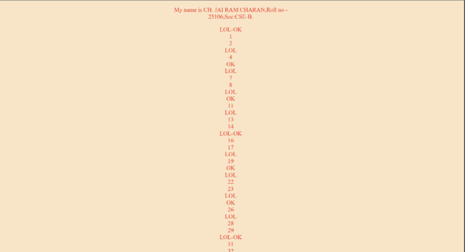
- Explanation:
- HTML-Hyper Text Markup Language.
- <DOCTYPE HTML>: Tells the browser about HTML version.
- <html>: Root element that contains the entire webpage
- <head>:Contains metadata and styles of the webpage
- <style>:Used to write CSS styling inside the HTML page
- <body>:Contains all visible content of the webpage
- <div>:Container used to group elements and apply styles
- <h1>:Main heading of the webpage
- <h3>:Sub-heading used for categories and details
- <p>:Defines paragraph text
- background-color: Sets the background color of an element
- The javascript must be written inside <script></script> tags
- Javascript can be written in either head or body.
- parseInt() → Converts the entered text into an integer number.
- document.write : Writens the value.
- For loop is used in the code.

- Write a JavaScript program to read 6 subjects marks from the student then compute the average marks of the student. Then, this average is used to determine the corresponding grade.
- Aim: To Write a JavaScript program to read 6 subjects marks from the student then compute the average marks of the student. Then, this average is used to determine the corresponding grade.
- Procedure:
- Input:
- <!DOCTYPE html>
- <html>
- <head>
- <style>
- body{
- text-align: center;
- display: flex;
- flex-direction: column;
- background-color: bisque;
- }
- div{
- box-shadow: 0 0 5px black;
- margin:auto auto;
- padding: 30px;
- width: fit-content;
- display: flex;
- flex-direction: column;
- border-radius: 10px;
- background-color: wheat;
- }
- div h3{
- background-color: red;
- color: white;
- padding: 10px;
- border-radius: 50px;
- }
- table{
- border: 1px solid black ;
- border-spacing: 0;
- }
- th,td{
- padding: 10px;
- }
- button{
- margin:10px;
- min-width:500px;
- font-size: larger;
- border-radius: 10px;
- border: none;
- background-color:red;
- color: white;
- padding: 10px;
- box-shadow: 0 0 2px black;
- }
- input{
- width: 50px;
- padding: 10px;
- }
- input :focus{
- border: 1px solid red ;
- }
- thead{
- background-color: rgb(206, 203, 203);
- }
- button:hover{
- transform: translateY(-2px);
- box-shadow: 0 2px 2px grey;
- }
- </style>
- </head>
- <body>
- <p style="text-align: center;color:red;font-size: large;">My name is CH. JAI RAM CHARAN,Roll no - 25106,Sec:CSE-B.</p>
- <div>
- <h3>Grade Claculator</h3>
- <table border="1">
- <thead>
- <tr>
- <th >S.NO</th>
- <th>Subject</th>
- <th>Marks</th>
- </tr>
- </thead>
- <tbody>
- <tr>
- <th>1</th>
- <td>Subject 1</td>
- <td><input type="number" name="mark1" value="0" min="0" max="100"></td>
- </tr>
- <tr>
- <th>2</th>
- <td>Subject 2</td>
- <td><input type="number" name="mark1" value="0" min="0" max="100"></td>
- </tr>
- <tr>
- <th>3</th>
- <td>Subject 3</td>
- <td><input type="number" name="mark1" value="0" class="mark1" min="0" max="100"></td>

- </tr>
- <tr>
- <th>4</th>
- <td>Subject 4</td>
- <td><input type="number" name="mark1" value="0" class="mark1" min="0" max="100"></td>

- </tr>
- <tr>
- <th>5</th>
- <td>Subject 5</td>
- <td><input type="number" name="mark1" value="0" class="mark1" min="0" max="100"></td>

- </tr>
- <tr>
- <th>6</th>
- <td>Subject 6</td>
- <td><input type="number" name="mark1" value="0" class="mark1" min="0" max="100"></td>
- </tr>
- </tbody>
- </table>

- <button type="button" onclick="calculate_marks()">Result</button>

- <table>
- <tr>
- <th>Total marks</th>
- <th>Percentage</th>
- <th>Average</th>
- <th>Grade</th>
- </tr>
- <tr>
- <td id="total_marks">-</td>
- <td id="percentage">-</td>
- <td id="average">-</td>
- <td id="grade">-</td>
- </tr>
- </table >
- </div>
- <script>
- function calculate_marks(){
- let elements = document.getElementsByTagName("input");
- var total = 0;
- for(let i=0;i<elements.length;i++){
- total+=parseInt(elements[i].value);
- }
- document.getElementById("total_marks").innerHTML=total;
- let average = total/6;
- document.getElementById("percentage").innerHTML=average;
- document.getElementById("average").innerHTML=average;
- document.getElementById("grade").innerHTML=grade(average);
- }
- function grade(average){
- if(average>=100){
- return "O"
- }
- else if(average>=90){
- return "A";
- }
- else if(average>=80){
- return "B";
- }
- else if(average>=70){
- return "C";
- }
- else if(average>=60){
- return "D";
- }
- else{
- return "F";
- }
- }
- </script>

- </body>
- </html>

- Output:
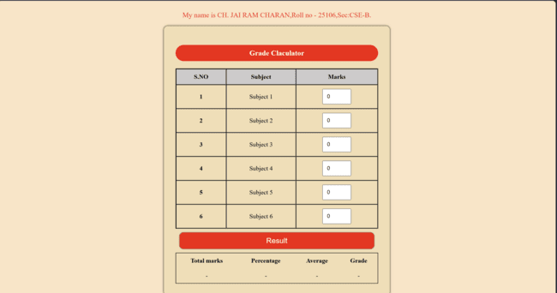

- Explanation:
- HTML-Hyper Text Markup Language.
- <DOCTYPE HTML>: Tells the browser about HTML version.
- <html>: Root element that contains the entire webpage
- <head>:Contains metadata and styles of the webpage
- <style>:Used to write CSS styling inside the HTML page
- <body>:Contains all visible content of the webpage
- <div>:Container used to group elements and apply styles
- <h1>:Main heading of the webpage
- <p>:Defines paragraph text
- background-color: Sets the background color of an element
- display: grid – This is used to create a layout system. It allows us to divide the page into rows and columns, making it easy to place different sections like the header, frames, and footer in required places.
- parseInt() – In the JavaScript part, this function is used to take the text typed in the input box and convert it into a integer.
- innerHTML – This property is used to change the content of an HTML element.
- document.getElementById("id") – This is the way JavaScript finds a specific element on the HTML page.
- Variables (var) – These are like small storage containers used to hold data.
- The javascript must be written inside <script></script> tags
- Javascript can be written in either head or body.
- Function – allows to create reusable code that can execute when called.

Week-11

- A website requires users to enter a username. The system should display a message while typing if the username is less than 5 characters.
- Aim: To make a website which requires users to enter a username. The system should display a message while typing if the username is less than 5 characters.
- Procedure:
- Input:
- <!DOCTYPE html>
- <html>
- <head>
- <title>Username Validation</title>
- </head>
- <body style="background-color: bisque;">
- <p style="text-align: center;color:red;font-size: large;">My name is CH. JAI RAM CHARAN,Roll no - 25106,Sec:CSE-B.</p>
- <h2>Enter Username</h2>
- <input type="text" id="username" onkeyup="checkUsername()" placeholder="Enter username">
- <p id="message"></p>

- <script>
- function checkUsername() {
- let username = document.getElementById("username").value;
- let message = document.getElementById("message");

- if (username.length < 5) {
- message.textContent = "Username must be at least 5 characters";
- message.style.color = "red";
- } else {
- message.textContent = "Username looks good!";
- message.style.color = "green";
- }
- }
- </script>

- </body>
- </html>

- Output;

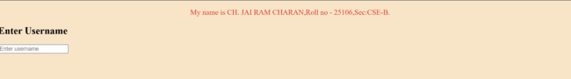

- Explanation:
- HTML-Hyper Text Markup Language.
- <DOCTYPE HTML>: Tells the browser about HTML version.
- <html>: Root element that contains the entire webpage
- <head>:Contains metadata and styles of the webpage
- <style>:Used to write CSS styling inside the HTML page
- <body>:Contains all visible content of the webpage
- <div>:Container used to group elements and apply styles
- <h1>:Main heading of the webpage
- <p>:Defines paragraph text
- background-color: Sets the background color of an element
- display: grid – This is used to create a layout system. It allows us to divide the page into rows and columns, making it easy to place different sections like the header, frames, and footer in required places.
- parseInt() – In the JavaScript part, this function is used to take the text typed in the input box and convert it into a integer.
- innerHTML – This property is used to change the content of an HTML element.
- document.getElementById("id") – This is the way JavaScript finds a specific element on the HTML page.
- Variables (var) – These are like small storage containers used to hold data.
- The javascript must be written inside <script></script> tags
- Javascript can be written in either head or body.
- Function – allows to create reusable code that can execute when called.
- Onkeyup – Validates the username on clicking it

- A registration form should validate email format before submission. If invalid, the form should not be submitted.
- Aim: To make a registration form which should validate email format before submission. If invalid, the form should not be submitted.
- Procedure:
- Input:
- <!DOCTYPE html>
- <html>
- <head>
- <title>Email Validation</title>
- </head>
- <body style="background-color: bisque;">
- <p style="text-align: center;color:red;font-size: large;">My name is CH. JAI RAM CHARAN,Roll no - 25106,Sec:CSE-B.</p>
- <h2>Registration Form</h2>

- <form onsubmit="return validateEmail()">
- <input type="text" id="email" placeholder="Enter email">
- <p id="error"></p>
- <button type="submit">Submit</button>
- </form>

- <script>
- function validateEmail() {
- var email = document.getElementById("email").value;
- var error = document.getElementById("error");
- var pattern = /^[a-zA-Z0-9._-]+@[a-zA-Z0-9.-]+\.[a-zA-Z]{2,4}$/;

- if (pattern.test(email)) {
- error.innerHTML = "";
- return true;
- } else {
- error.innerHTML = "Invalid email format";
- error.style.color = "red";
- return false;
- }
- }
- </script>

- </body>
- </html>

- Output:
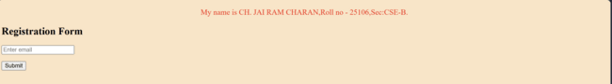

- Explanation:
- HTML-Hyper Text Markup Language.
- <DOCTYPE HTML>: Tells the browser about HTML version.
- <html>: Root element that contains the entire webpage
- <head>:Contains metadata and styles of the webpage
- <style>:Used to write CSS styling inside the HTML page
- <body>:Contains all visible content of the webpage
- <div>:Container used to group elements and apply styles
- <h1>:Main heading of the webpage
- <p>:Defines paragraph text
- background-color: Sets the background color of an element
- display: grid – This is used to create a layout system. It allows us to divide the page into rows and columns, making it easy to place different sections like the header, frames, and footer in required places.
- parseInt() – In the JavaScript part, this function is used to take the text typed in the input box and convert it into a integer.
- innerHTML – This property is used to change the content of an HTML element.
- document.getElementById("id") – This is the way JavaScript finds a specific element on the HTML page.
- Variables (var) – These are like small storage containers used to hold data.
- The javascript must be written inside <script></script> tags
- Javascript can be written in either head or body.
- Function – allows to create reusable code that can execute when called.
- We used conditional statements to validate the email.

- A system should check password strength while typing and display whether it is weak or strong.
- Aim: To write a code for which system should check password strength while typing and display whether it is weak or strong.
- Procedure:
- Input:
- <!DOCTYPE html>
- <html>
- <head>
- <title>Password Strength Checker</title>
- </head>
- <body style="background-color: bisque;">
- <p style="text-align: center;color:red;font-size: large;">My name is CH. JAI RAM CHARAN,Roll no - 25106,Sec:CSE-B.</p>
- <h2>Check Password Strength</h2>

- <input type="password" id="password" placeholder="Enter password" oninput="checkStrength()">
- <p id="result"></p>

- <script>
- function checkStrength() {
- var password = document.getElementById("password").value;
- var result = document.getElementById("result");

- if (password.length < 5) {
- result.innerHTML = "Weak Password";
- result.style.color = "red";
- }
- else if (password.match(/[a-z]/) &&
- password.match(/[0-9]/) &&
- password.match(/[@$!%*?&]/)) {
- result.innerHTML = "Strong Password";
- result.style.color = "green";
- }
- else {
- result.innerHTML = "Medium Password";
- result.style.color = "orange";
- }
- }
- </script>

- </body>
- </html>

- Output:

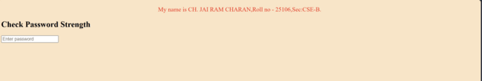

- Explanation:
- HTML-Hyper Text Markup Language.
- <DOCTYPE HTML>: Tells the browser about HTML version.
- <html>: Root element that contains the entire webpage
- <head>:Contains metadata and styles of the webpage
- <style>:Used to write CSS styling inside the HTML page
- <body>:Contains all visible content of the webpage
- <div>:Container used to group elements and apply styles
- <h1>:Main heading of the webpage
- <p>:Defines paragraph text
- background-color: Sets the background color of an element
- display: grid – This is used to create a layout system. It allows us to divide the page into rows and columns, making it easy to place different sections like the header, frames, and footer in required places.
- parseInt() – In the JavaScript part, this function is used to take the text typed in the input box and convert it into a integer.
- innerHTML – This property is used to change the content of an HTML element.
- document.getElementById("id") – This is the way JavaScript finds a specific element on the HTML page.
- Variables (var) – These are like small storage containers used to hold data.
- The javascript must be written inside <script></script> tags
- Javascript can be written in either head or body.
- Function – allows to create reusable code that can execute when called.
- We used conditional statements to validate the password.

- A form should validate a mobile number when the user leaves the input field. The number must be exactly 10 digits.
- Aim: To make a form which should validate a mobile number when the user leaves the input field. The number must be exactly 10 digits.
- Procedure:
- Input:
- <!DOCTYPE html>
- <html>
- <head>
- <title>Mobile Number Validation</title>
- <script>
- function validateMobile() {
- let mobile = document.getElementById("mobile").value;
- let message = document.getElementById("msg");

- let pattern = /^[0-9]{10}$/;

- if (!pattern.test(mobile)) {
- message.innerHTML = " Enter a valid 10-digit mobile number";
- message.style.color = "red";
- } else {
- message.innerHTML = " Valid mobile number";
- message.style.color = "green";
- }
- }
- </script>
- </head>

- <body style="background-color: bisque;">
- <p style="text-align: center;color:red;font-size: large;">My name is CH. JAI RAM CHARAN,Roll no - 25106,Sec:CSE-B.</p>
- <h2>Mobile Number Validation</h2>

- <form>
- <label>Enter Mobile Number:</label><br><br>
- <input type="text" id="mobile" onblur="validateMobile()">
- <p id="msg"></p>
- </form>

- </body>
- </html>

- Output:
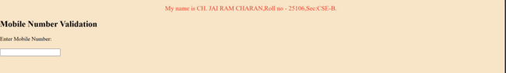

- Explanation:
- HTML-Hyper Text Markup Language.
- <DOCTYPE HTML>: Tells the browser about HTML version.
- <html>: Root element that contains the entire webpage
- <head>:Contains metadata and styles of the webpage
- <style>:Used to write CSS styling inside the HTML page
- <body>:Contains all visible content of the webpage
- <div>:Container used to group elements and apply styles
- <h1>:Main heading of the webpage
- <p>:Defines paragraph text
- background-color: Sets the background color of an element
- display: grid – This is used to create a layout system. It allows us to divide the page into rows and columns, making it easy to place different sections like the header, frames, and footer in required places.
- parseInt() – In the JavaScript part, this function is used to take the text typed in the input box and convert it into a integer.
- innerHTML – This property is used to change the content of an HTML element.
- document.getElementById("id") – This is the way JavaScript finds a specific element on the HTML page.
- Variables (var) – These are like small storage containers used to hold data.
- The javascript must be written inside <script></script> tags
- Javascript can be written in either head or body.
- Function – allows to create reusable code that can execute when called.
- We used conditional statements to validate the mobile number.

- Design an HTML page, such that the registration form must validate:
Name (not empty),Email (valid format),Password (minimum 6 characters)
- Aim: To design an HTML page, such that the registration form must validate:
Name (not empty),Email (valid format),Password (minimum 6 characters)
- Procedure:
- Input:
- <!DOCTYPE html>
- <html>
- <head>
- <title>Registration Form Validation</title>
- <style>
- body {
- font-family: Arial;
- background-color: bisque;
- text-align: center;
- }
- form {
- background: wheat;
- padding: 20px;
- margin: auto;
- width: 300px;
- border-radius: 10px;
- }
- input {
- width: 90%;
- padding: 8px;
- margin: 10px 0;
- }
- .error {
- color: red;
- font-size: 14px;
- }
- </style>

- <script>
- function validateForm() {
- let name = document.getElementById("name").value;
- let email = document.getElementById("email").value;
- let password = document.getElementById("password").value;

- let nameError = document.getElementById("nameError");
- let emailError = document.getElementById("emailError");
- let passError = document.getElementById("passError");

- nameError.innerHTML = "";
- emailError.innerHTML = "";
- passError.innerHTML = "";

- let valid = true;

- if (name === "") {
- nameError.innerHTML = "Name cannot be empty";
- valid = false;
- }

- let emailPattern = /^[a-zA-Z0-9._-]+@[a-zA-Z0-9.-]+\.[a-zA-Z]{2,4}$/;
- if (!emailPattern.test(email)) {
- emailError.innerHTML = "Enter a valid email";
- valid = false;
- }

- if (password.length < 6) {
- passError.innerHTML = "Password must be at least 6 characters";
- valid = false;
- }
- return valid;
- }
- </script>
- </head>

- <body>
- <p style="text-align: center;color:red;font-size: large;">My name is CH. JAI RAM CHARAN,Roll no - 25106,Sec:CSE-B.</p>
- <h2>Registration Form</h2>

- <form onsubmit="return validateForm()">
- <input type="text" id="name" placeholder="Enter Name">
- <div id="nameError" class="error"></div>

- <input type="text" id="email" placeholder="Enter Email">
- <div id="emailError" class="error"></div>

- <input type="password" id="password" placeholder="Enter Password">
- <div id="passError" class="error"></div>

- <input type="submit" value="Register">
- </form>

- </body>
- </html>

- Output:

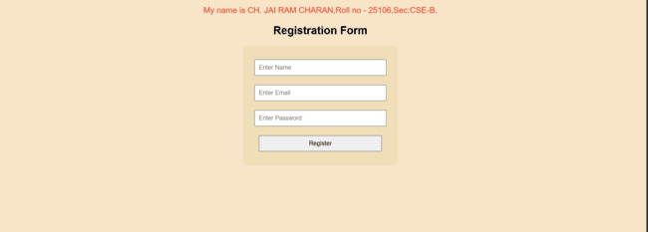

- Explanation:
- HTML-Hyper Text Markup Language.
- <DOCTYPE HTML>: Tells the browser about HTML version.
- <html>: Root element that contains the entire webpage
- <head>:Contains metadata and styles of the webpage
- <style>:Used to write CSS styling inside the HTML page
- <body>:Contains all visible content of the webpage
- <div>:Container used to group elements and apply styles
- <h1>:Main heading of the webpage
- <p>:Defines paragraph text
- background-color: Sets the background color of an element
- display: grid – This is used to create a layout system. It allows us to divide the page into rows and columns, making it easy to place different sections like the header, frames, and footer in required places.
- parseInt() – In the JavaScript part, this function is used to take the text typed in the input box and convert it into a integer.
- innerHTML – This property is used to change the content of an HTML element.
- document.getElementById("id") – This is the way JavaScript finds a specific element on the HTML page.
- Variables (var) – These are like small storage containers used to hold data.
- The javascript must be written inside <script></script> tags
- Javascript can be written in either head or body.
- Function – allows to create reusable code that can execute when called.
Week-12
- The setup and installation process of Electron.js and node.js corresponding to its output.
- Aim: To the setup and installation process of Electron.js and node.js corresponding to its output.
- Step-1: Go to Node.js website and download the Node.js for windows. The LTS version is preffered.
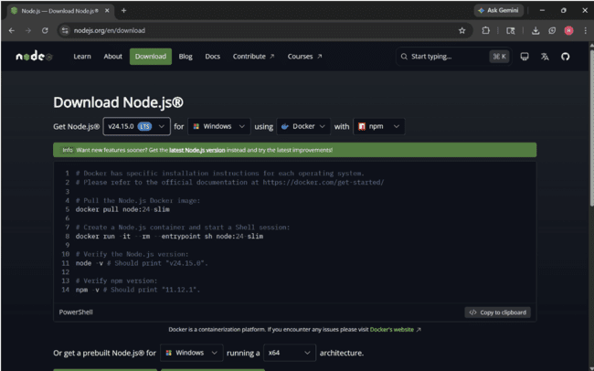
- Step-2: Now open the node.js installer and click next, accept and agree the licence and other agreements.
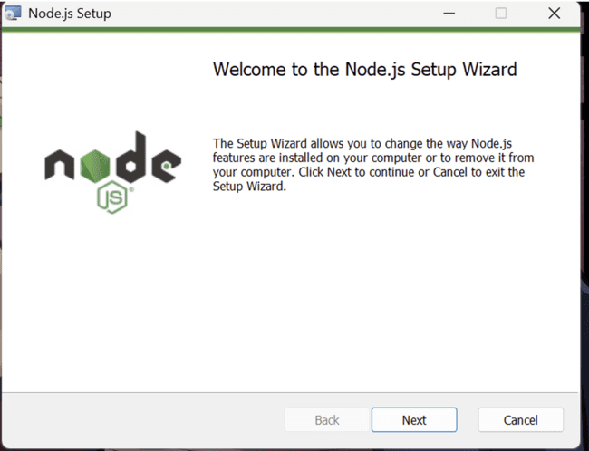
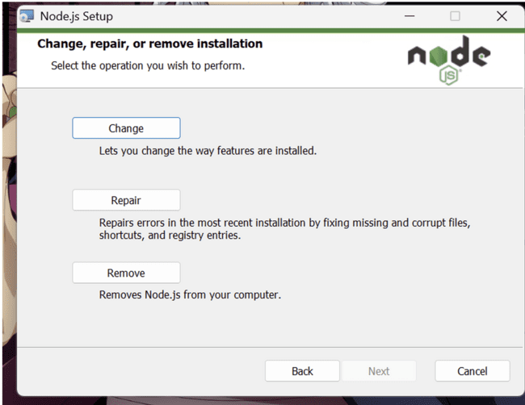

- Step-3: Click on next to install Node.js in the system.
- Step-4: To check if node.js is installed, open terminal and provide node –v in the command , then if the node.js is installed then you can find the installed version number. This shows that Node.js is successfully installed.
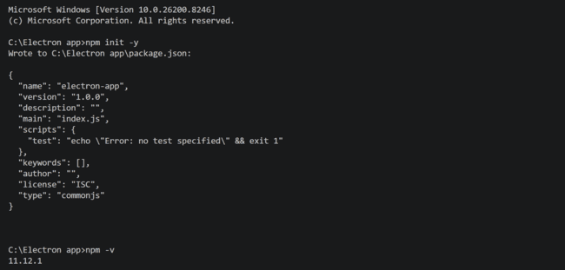
- Step-5: Open command and provide npm init -y to configure npm
- Step-6: To install electron app, open the folder in which the electron app is needed to be installed, open it using vs code and in the terminal provide npm install electron –save-dev as a command then the packages will be installed in that folder.
